

**Discipline**

**LAMP Stack**

**CS5002**

Activity-19

**Sheikh Muhammed Tadeeb (AU19B1014)**

* **Problem Statement:**

1. Create a LAMP server and capture all the screens for the configuration.
2. Create a User-data script to automate this and share its images as well.

* **Theory:**
* **Brief:**

LAMP stands for Linux, Apache, MySQL, and PHP. Together, they provide a proven set of software for delivering high-performance web applications and as it contains PHP it works with Apache to help us create dynamic web pages as well.

* **Architecture:**

LAMP has a classic layered architecture, with Linux at the lowest level. The next layer is Apache and MySQL, followed by PHP. Although PHP is nominally at the top or presentation layer, the PHP component sits inside Apache.

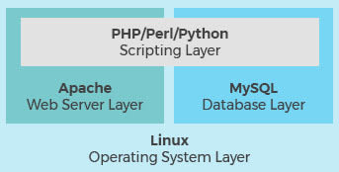

* **LAMP Working (layer-interoperability):**

A high-level look at the LAMP stack order of execution shows how the elements interoperate. The process starts when the Apache web server receives requests for web pages from a user’s browser. If the request is for a PHP file, Apache passes the request to PHP, which loads the file and executes the code contained in the file. PHP also communicates with MySQL to fetch any data referenced in the code.

PHP then uses the code in the file and the data from the database to create the HTML that browsers require to display web pages. The LAMP stack is efficient at handling not only static web pages, but also dynamic pages where the content may change each time it is loaded depending on the date, time, user identity and other factors.

After running the file code, PHP then passes the resulting data back to the Apache web server to send to the browser. It can also store this new data in MySQL. And of course, all of these operations are enabled by the Linux operating system running at the base of the stack.

* **Solution 1, Practical (Preparing the LAMP server):**
* **Step1)** Launching a new instance using Amazon Linux 2 with security group allowing SSH (port 22), HTTP (port 80), and HTTPS (port 443) connections.

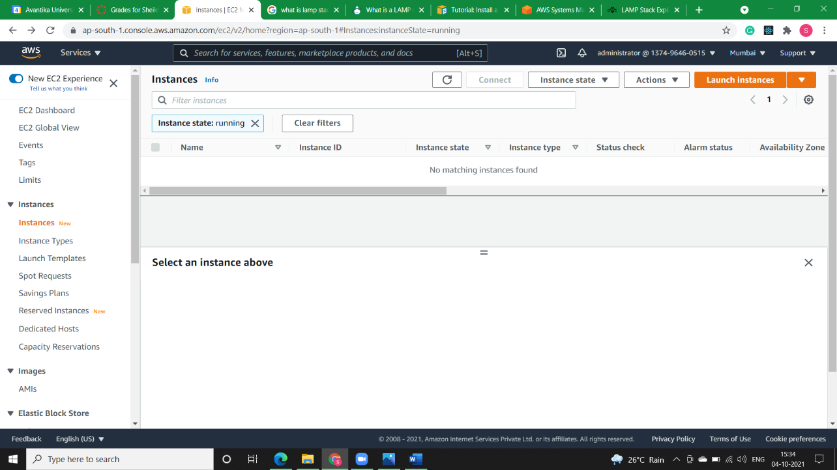

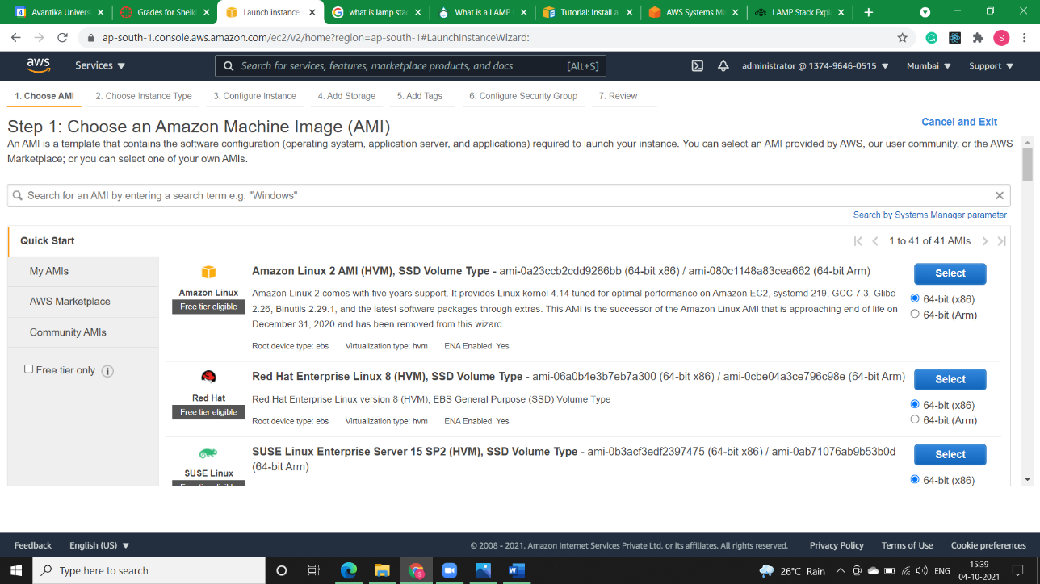

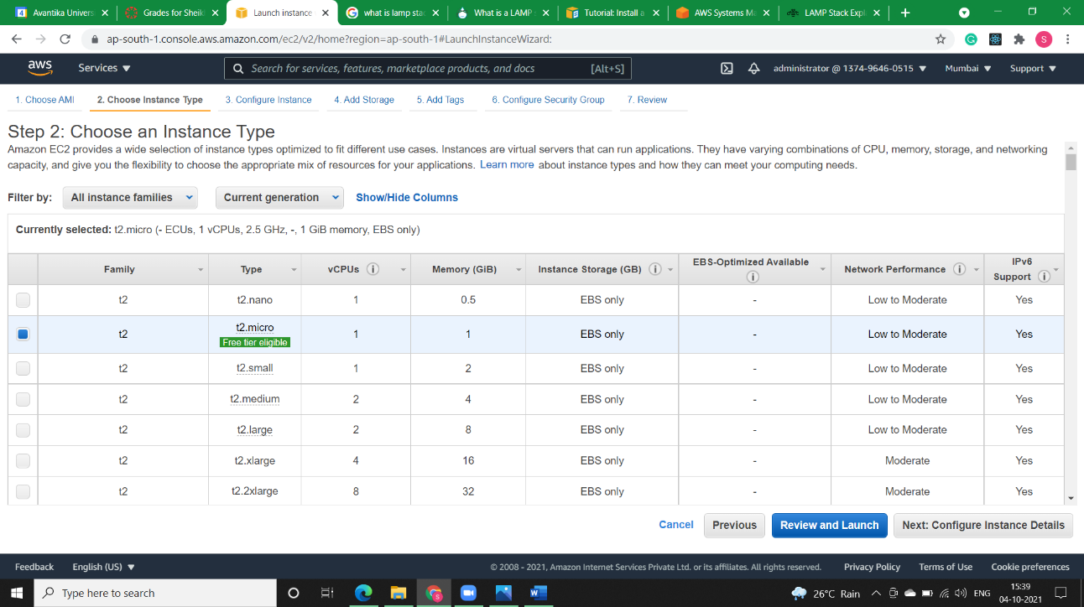

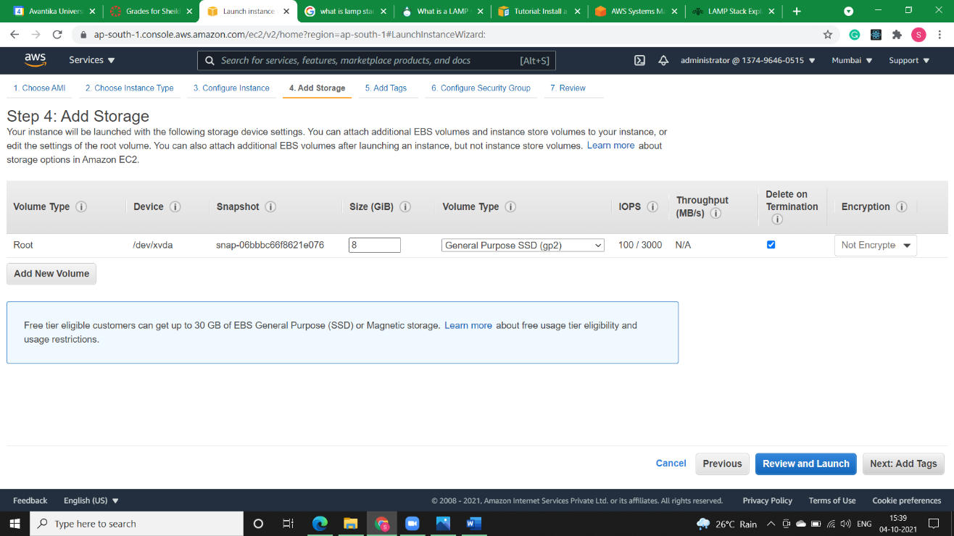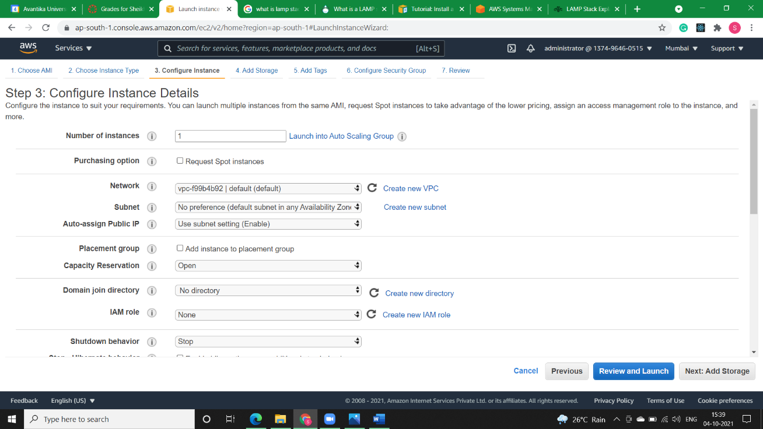

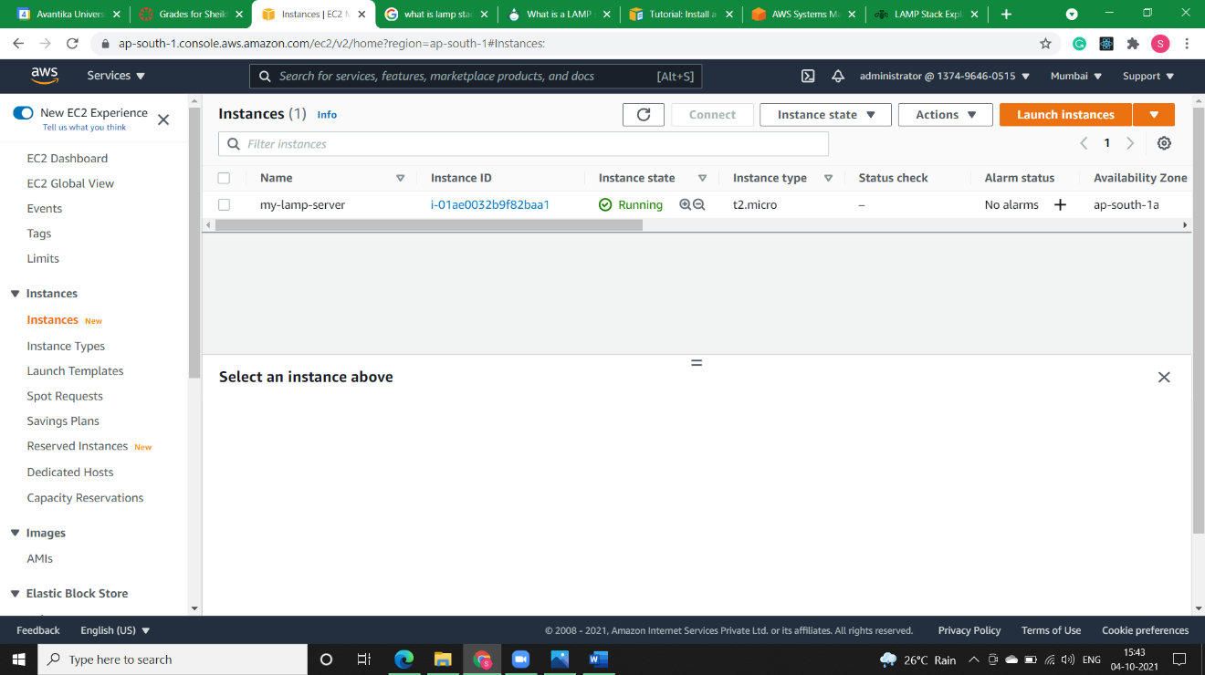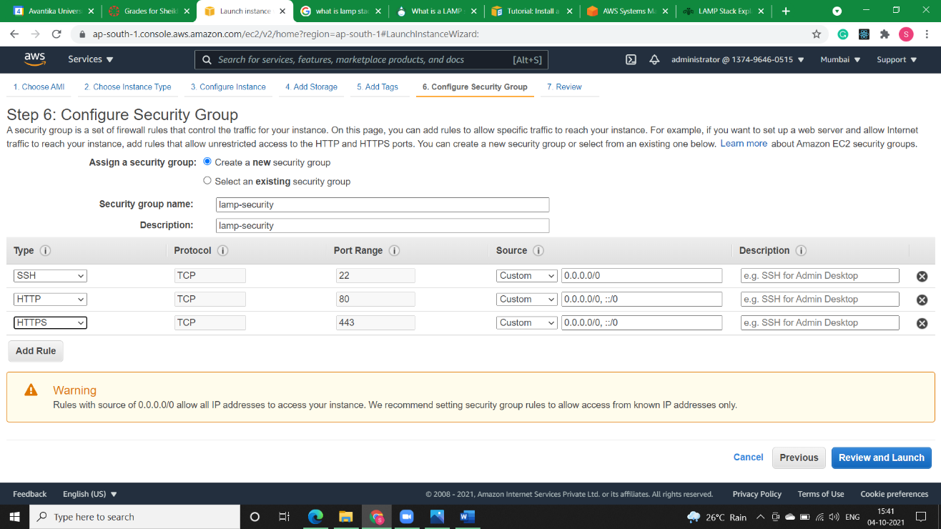

* **Step2)** Opening putty to check whether we are connected to our instance or not.

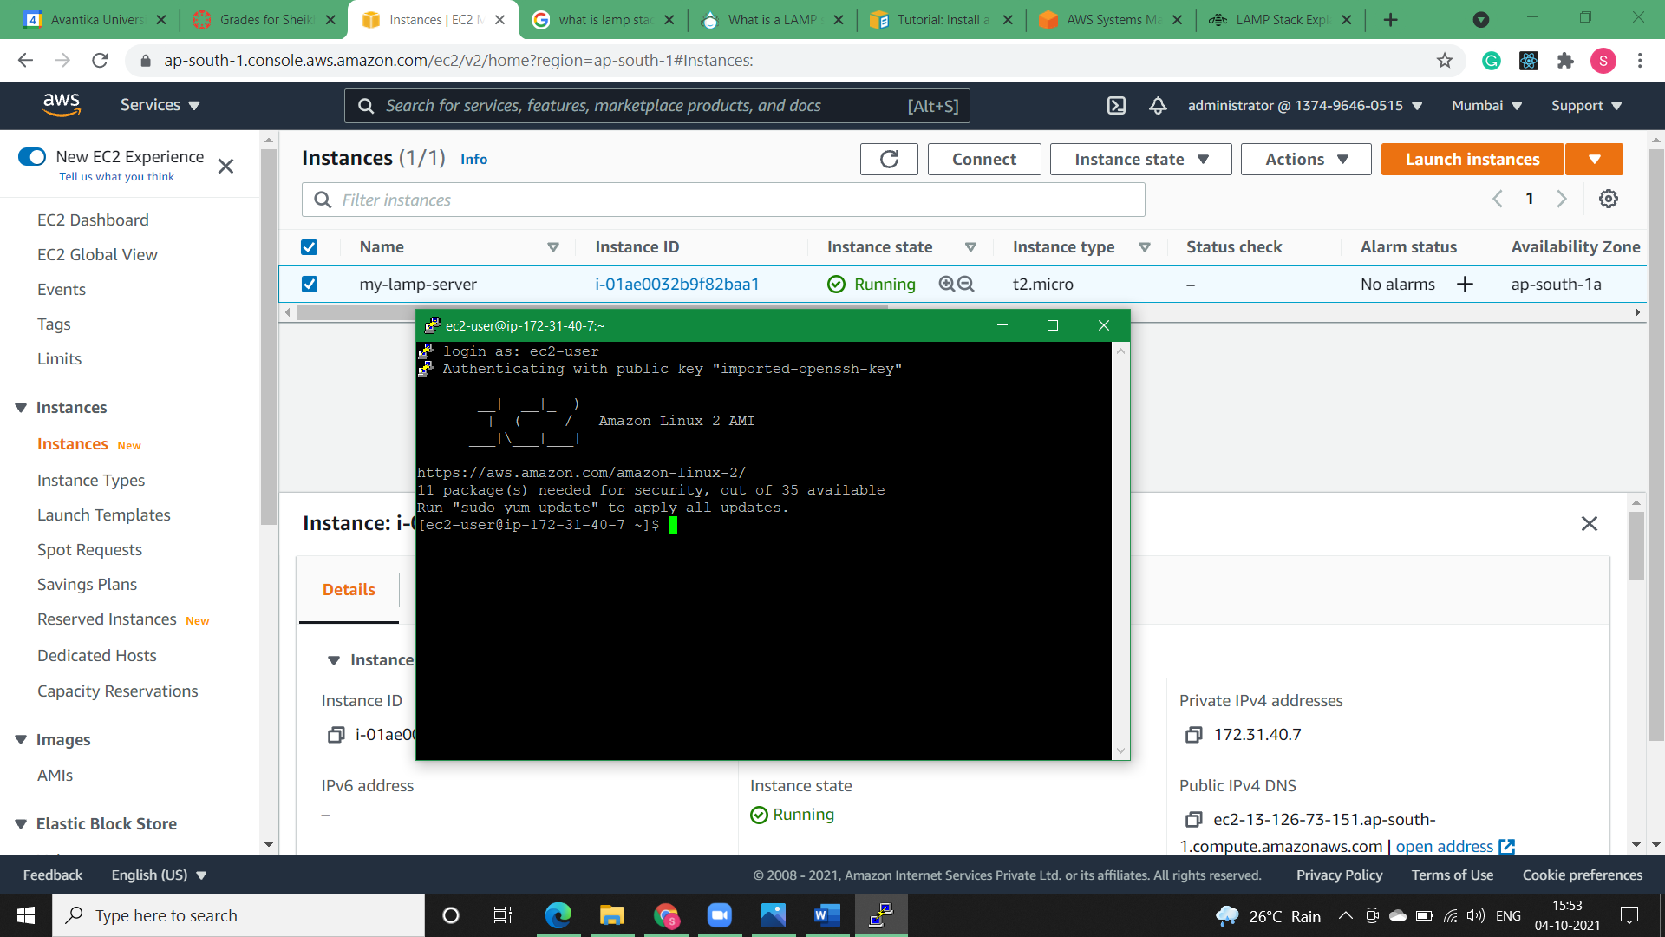

* **Step3)** To ensure that all of your software packages are up to date, perform a quick software update on your instance. This process may take a few minutes, but it is important to make sure that you have the latest security updates and bug fixes.

The -y option installs the updates without asking for confirmation. If you would like to examine the updates before installing, you can omit this option

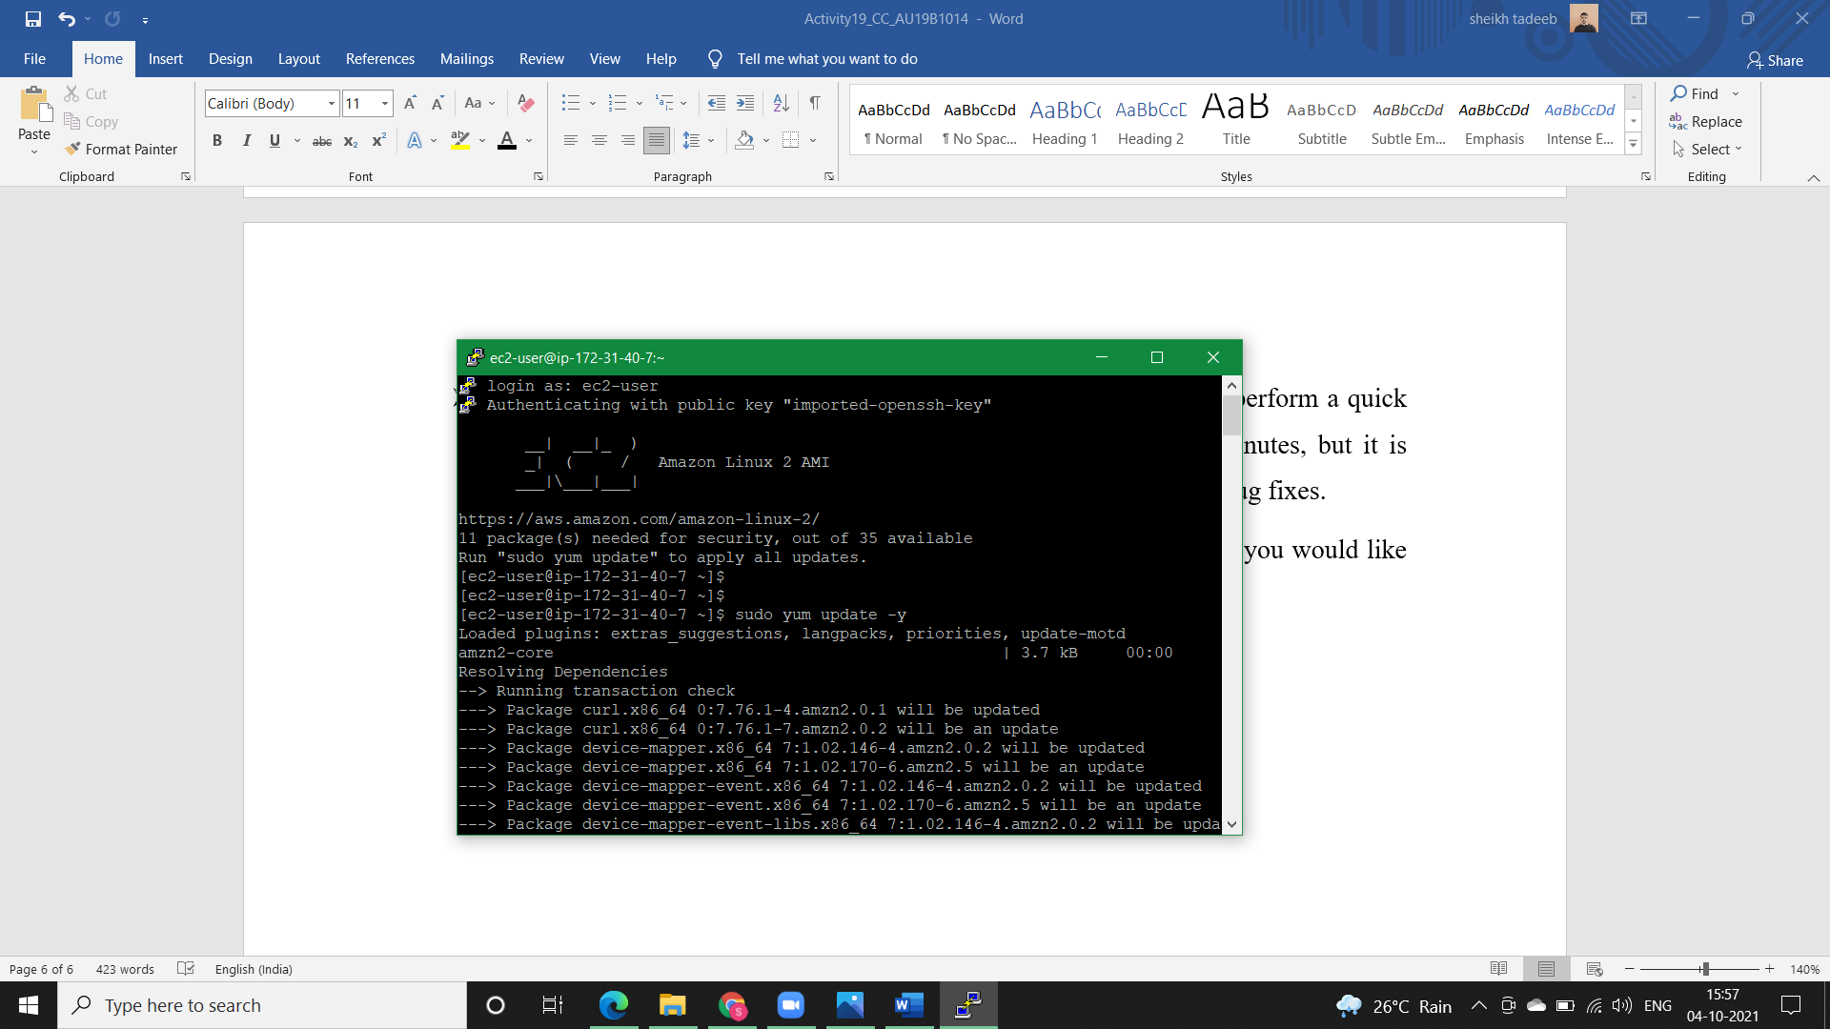

* **Step4)** Install the lamp-mariadb10.2-php7.2 and php7.2 Amazon Linux Extras repositories to get the latest versions of the LAMP MariaDB and PHP packages for Amazon Linux 2.

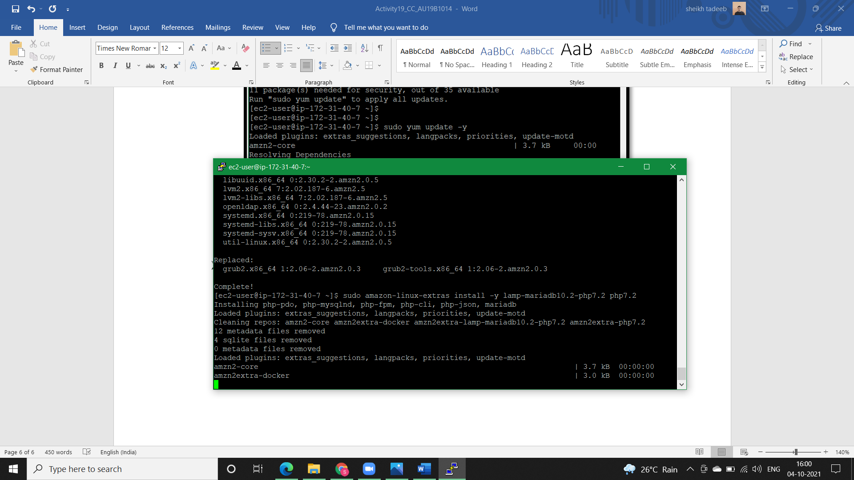

* **Step5)** We can check information about our instance using system-release.

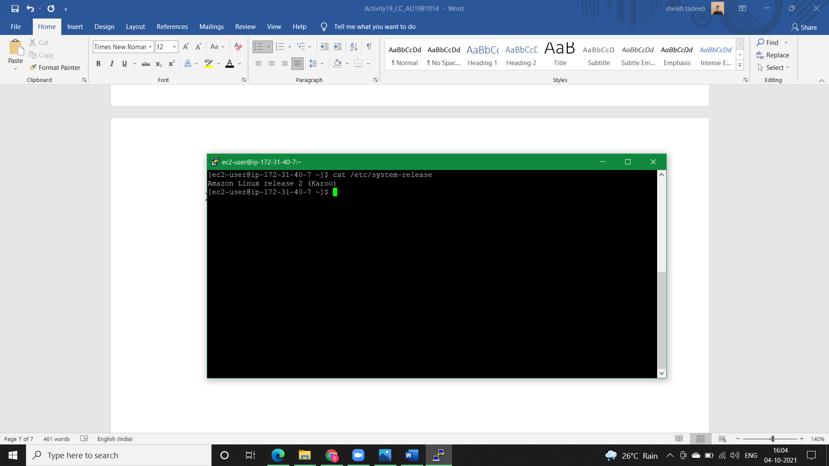

* **Step6)** Now that your instance is current, you can install the Apache web server, MariaDB, and PHP software packages.

Use the *yum install* command to install multiple software packages and all related dependencies at the same time.

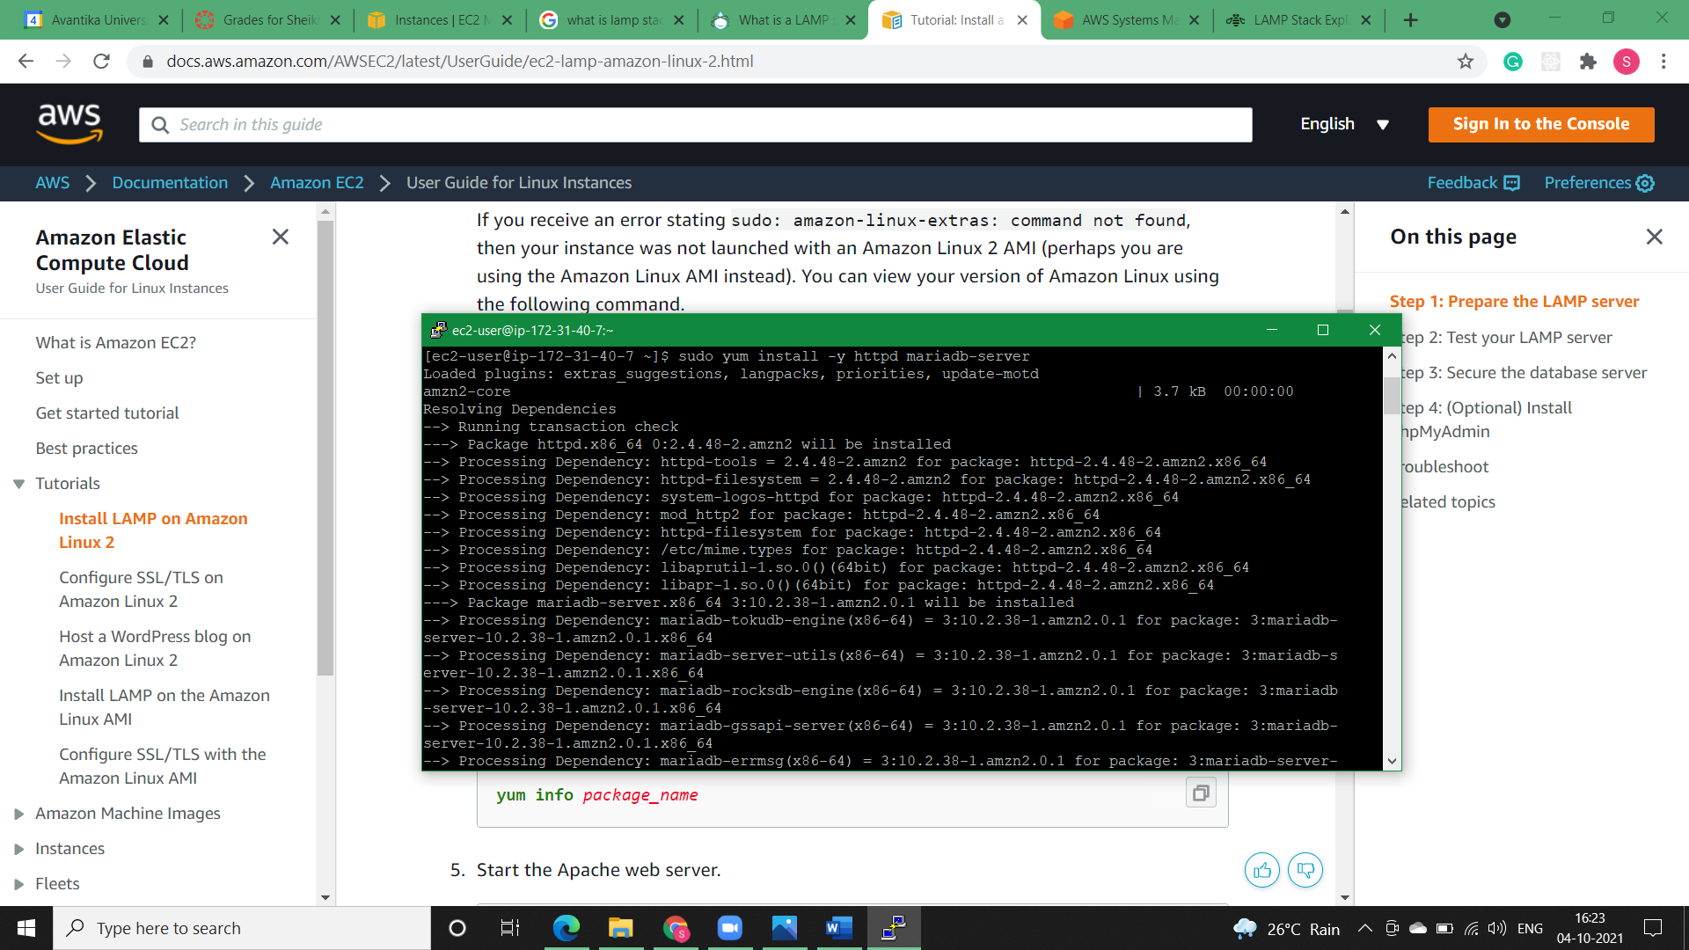

* **Step7)** Start the Apache web server and check its status.

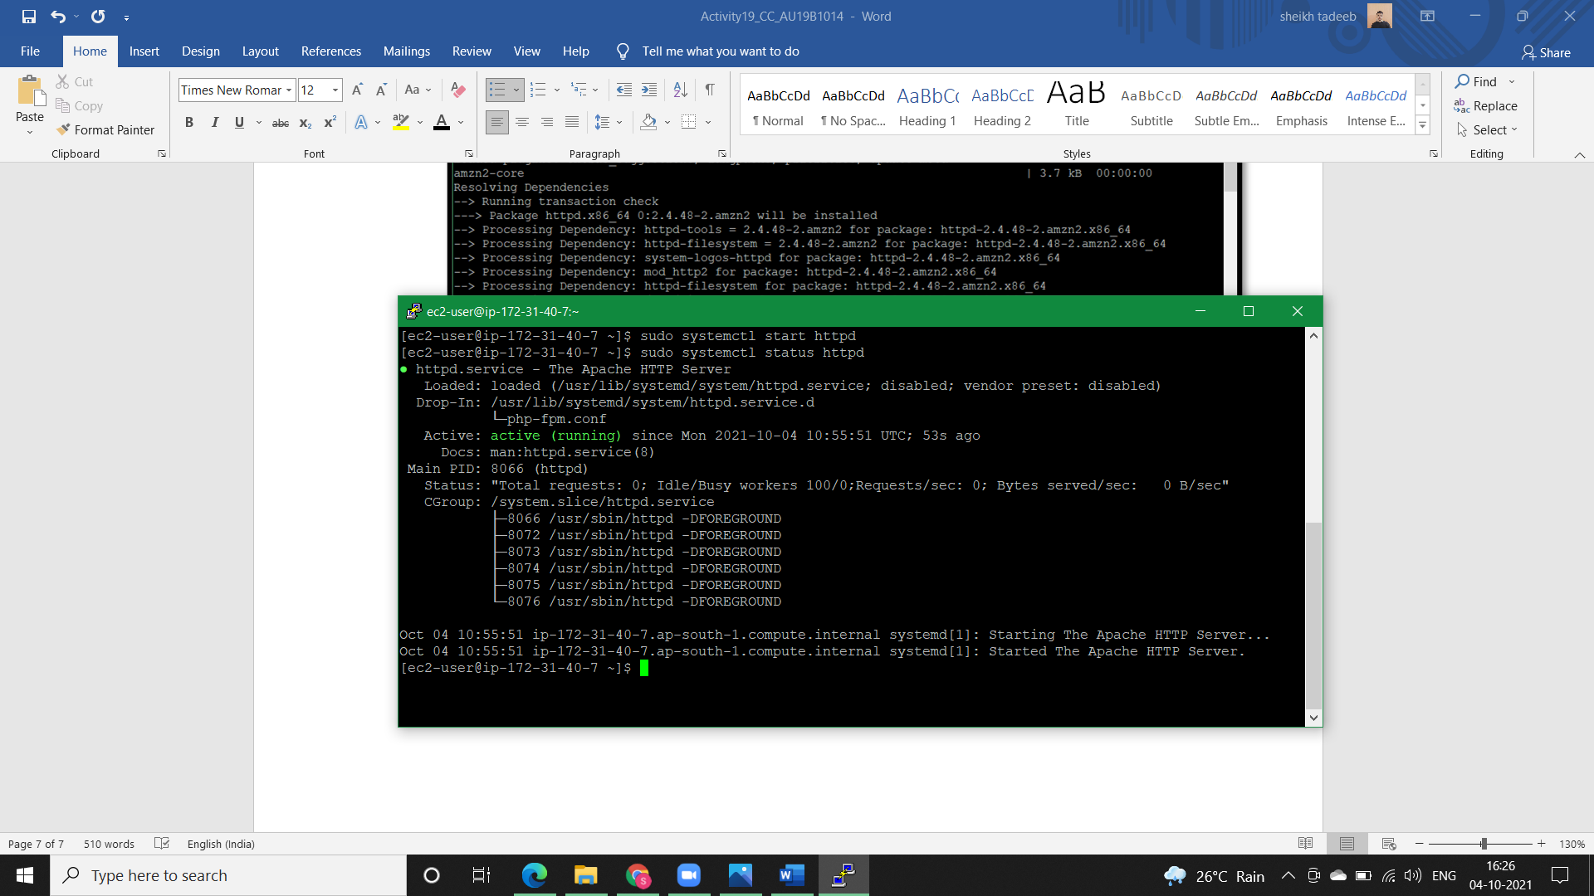

* **Step8)** Use the *systemctl* command to configure the Apache web server to start at each system boot and check whether httpd is running or not.

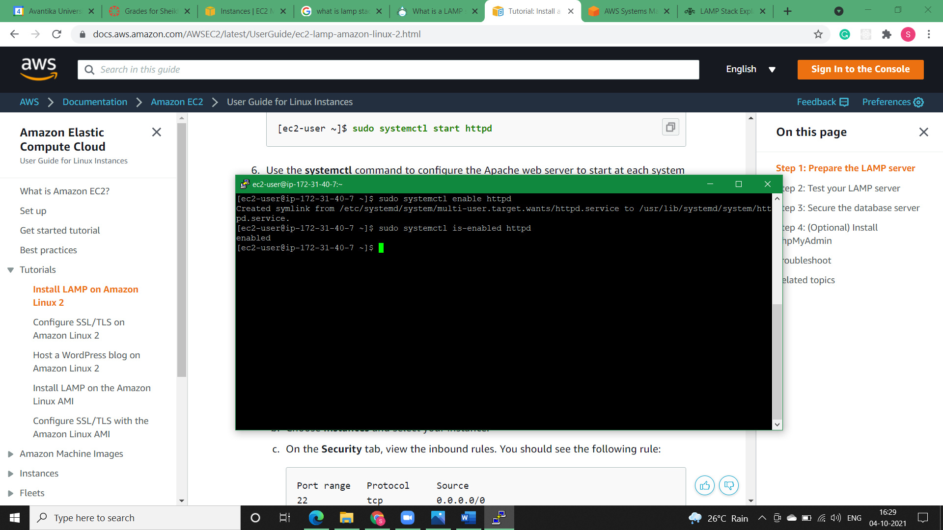

* **Step9)** Test our web server. In a web browser, type the public DNS address (or the public IP address) of our instance. If there is no content in /var/www/html, we should see the Apache test page. We can get the public DNS for our instance using the Amazon EC2 console (check the Public DNS column; if this column is hidden, choose Show/Hide Columns (the gear-shaped icon) and choose Public DNS).

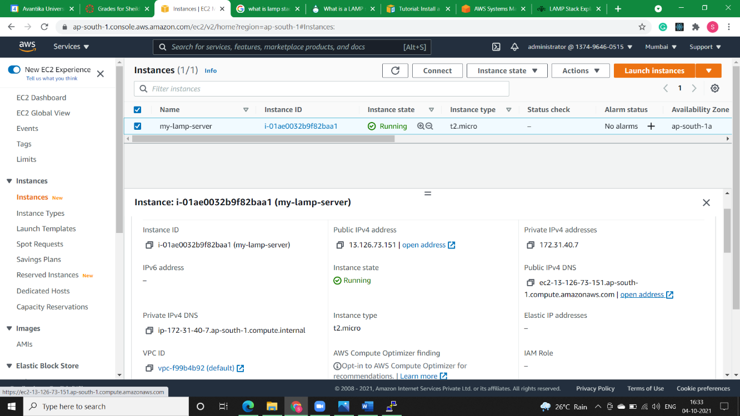

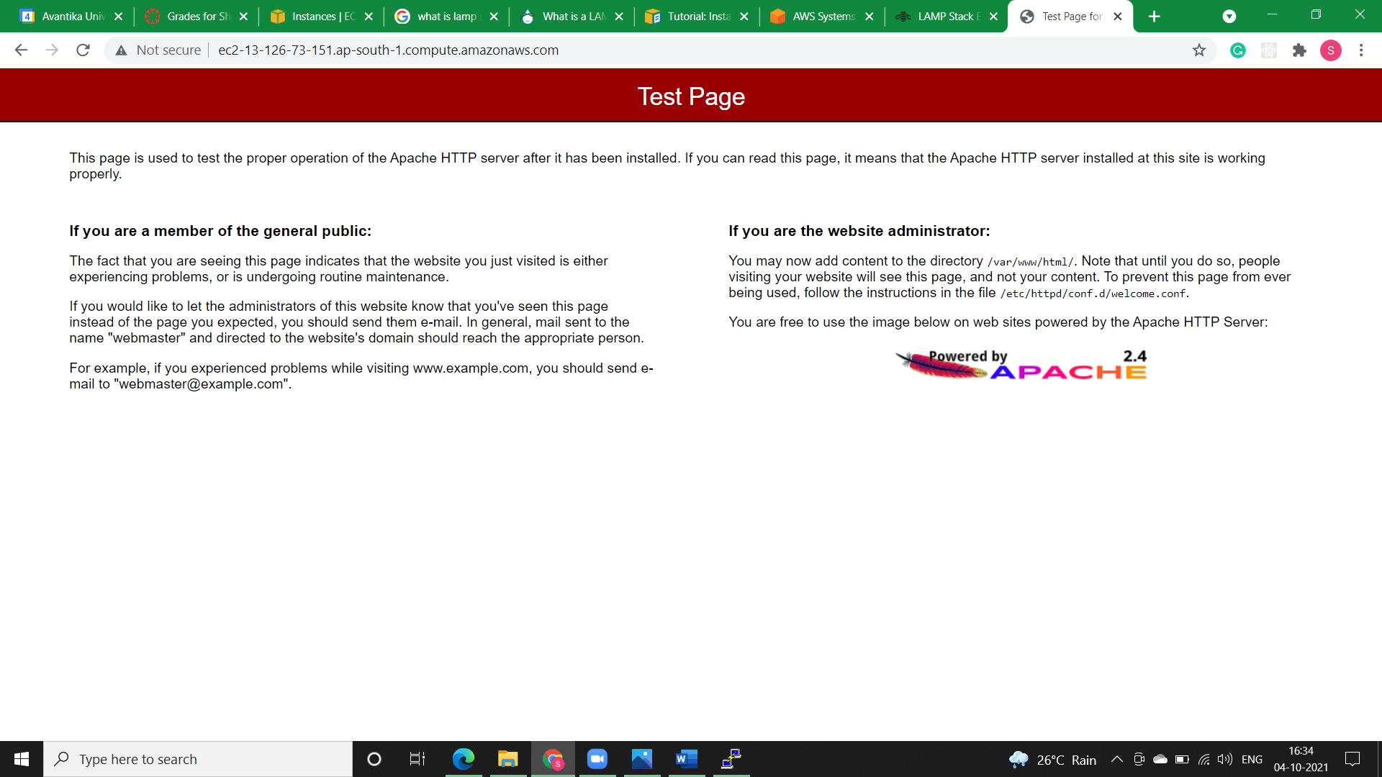

* **Step10)** Apache *httpd* serves files that are kept in a directory called the Apache document root. The Amazon Linux Apache document root is /var/www/html, which by default is owned by root.

To allow the ec2-user account to manipulate files in this directory, we must modify the ownership and permissions of the directory. There are many ways to accomplish this task. We add ec2-user to the apache group, to give the apache group ownership of the /var/www directory and assign write permissions to the group.

* **Step10.1)** Add your user (in this case, ec2-user) to the apache group and after this log-out to verify our membership.

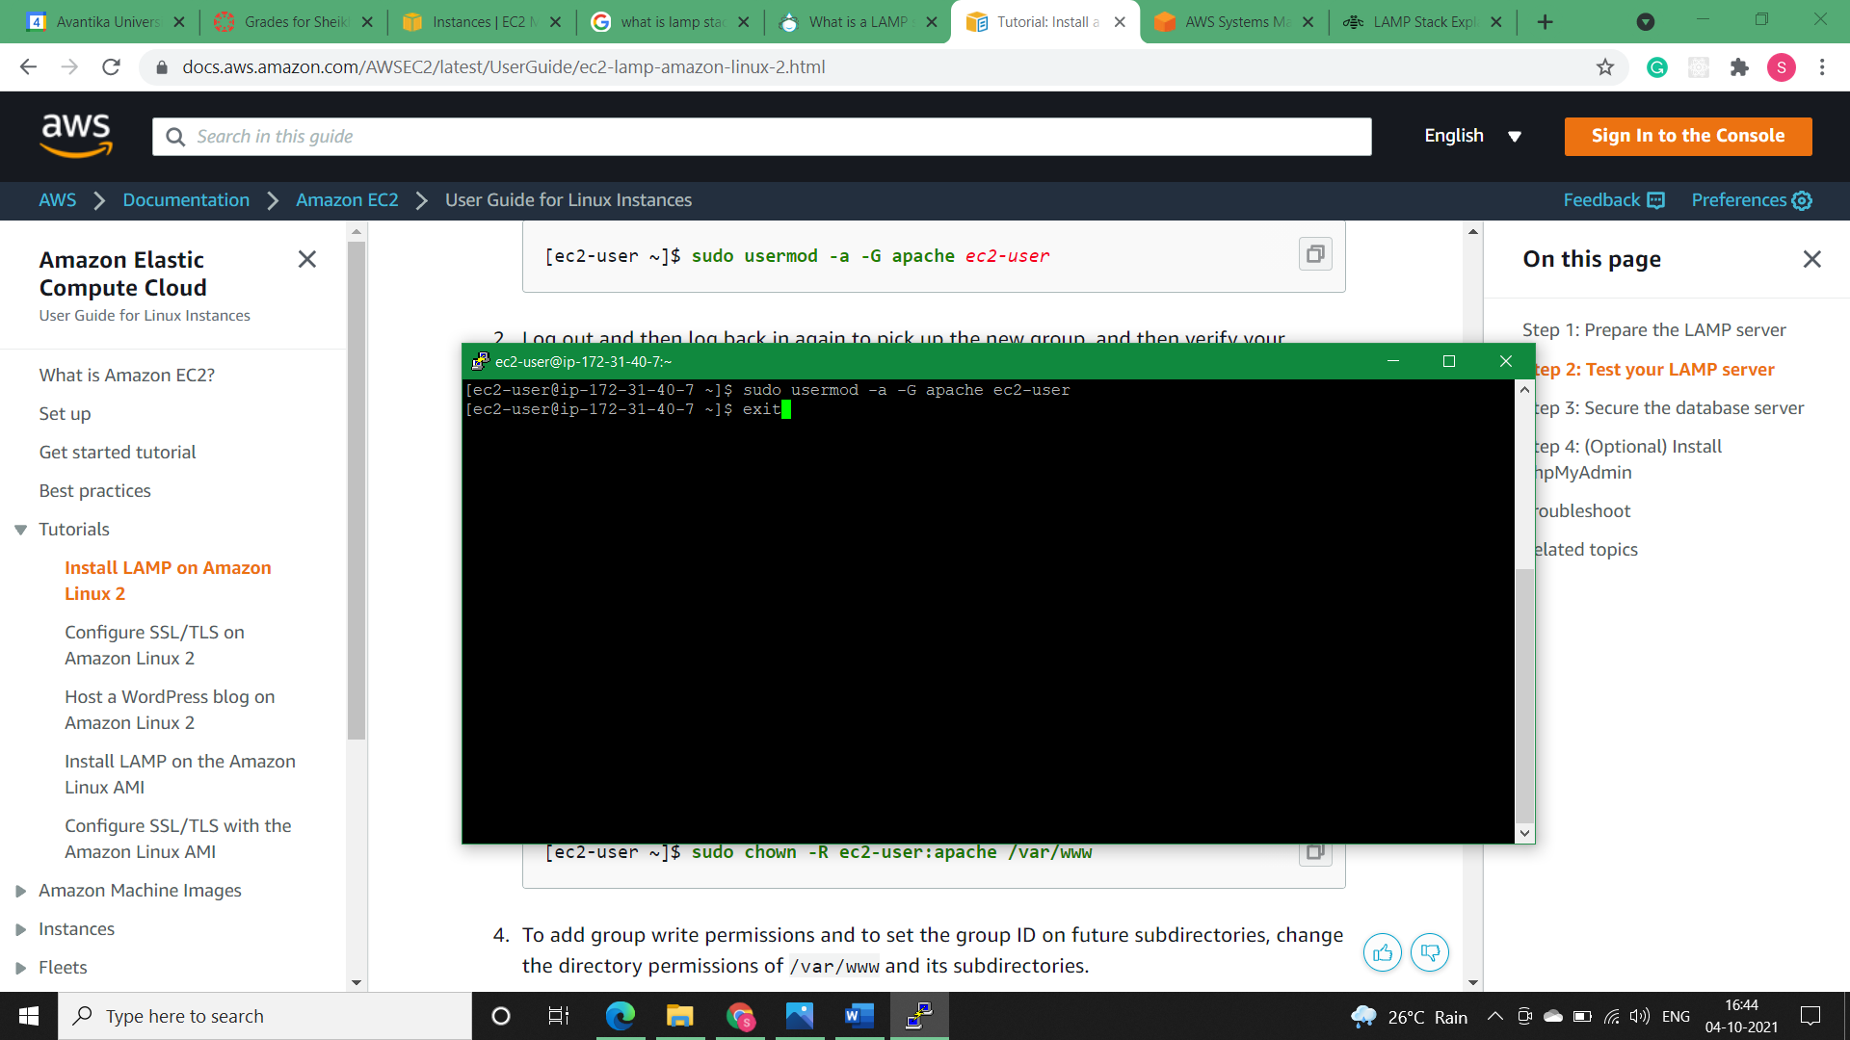

* **Step10.2)** To verify our membership in the apache group, we’ll reconnect to our instance, and then run the following command:

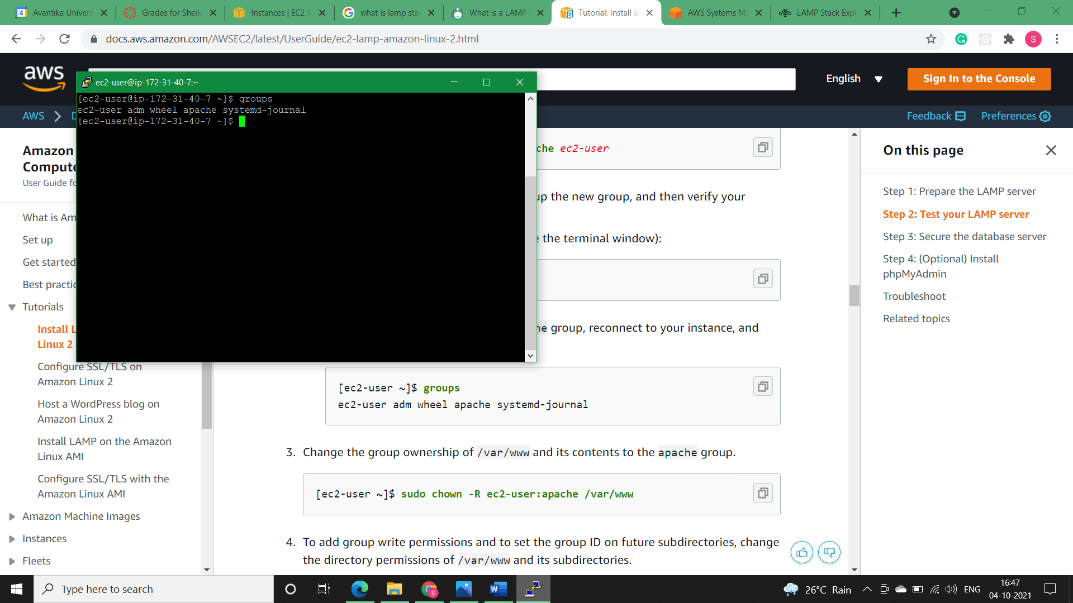

* **Step11)** Change the group ownership of /var/www and its contents to the apache group.

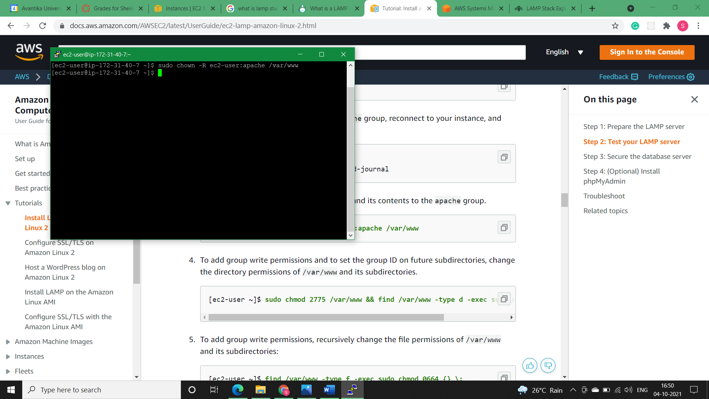

* **Step12)** To add group write permissions and to set the group ID on future subdirectories, change the directory permissions of /var/www and its subdirectories.



* **Step13)** To add group write permissions, recursively change the file permissions of /var/www and its subdirectories:

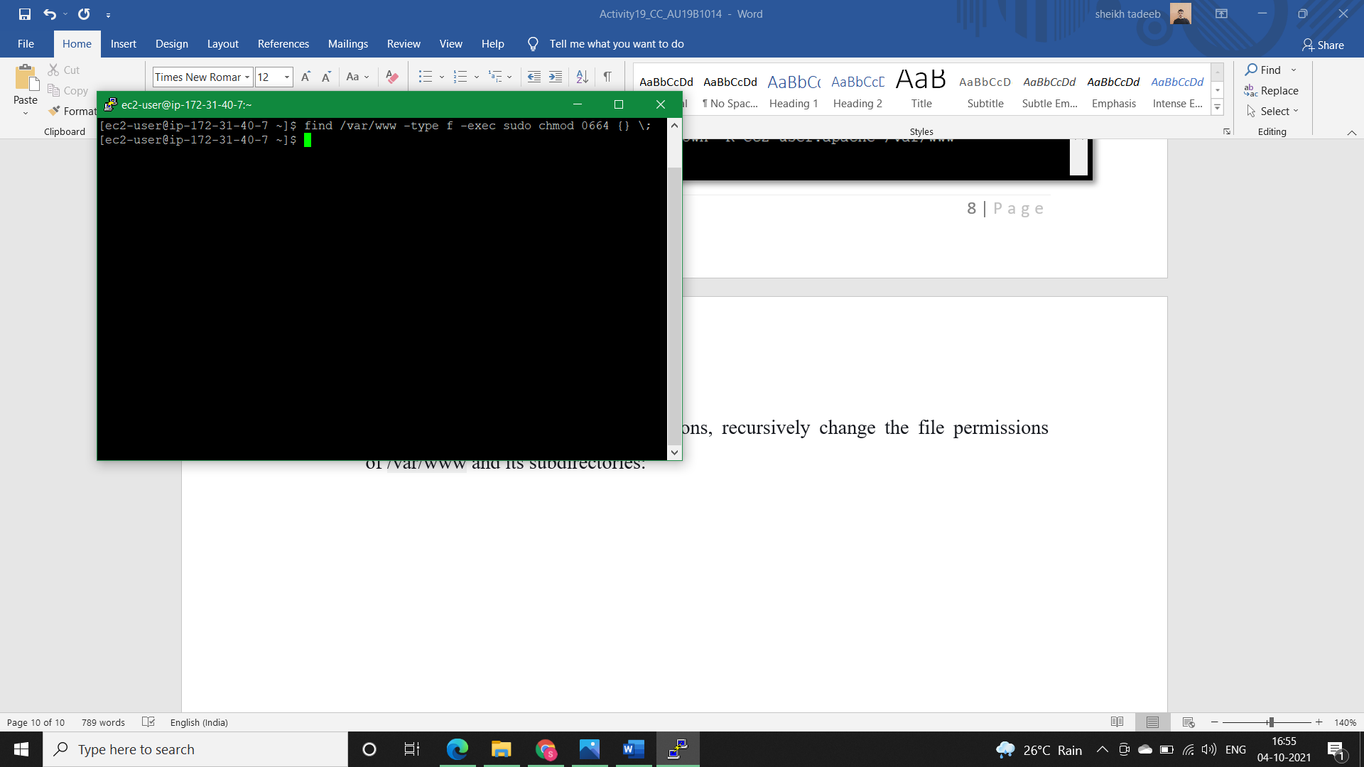

**NOTE:** Now, ec2-user (and any future members of the apache group) can add, delete, and edit files in the Apache document root, enabling you to add content, such as a static website or a PHP application.

* **Solution 1, Practical (Testing the LAMP server):**
* **Brief:**

If our server is installed and running, and our file permissions are set correctly, our ec2-user account should be able to create a PHP file in the /var/www/html directory that is available from the internet.

* **Step1)** Create a PHP file in the Apache document root.

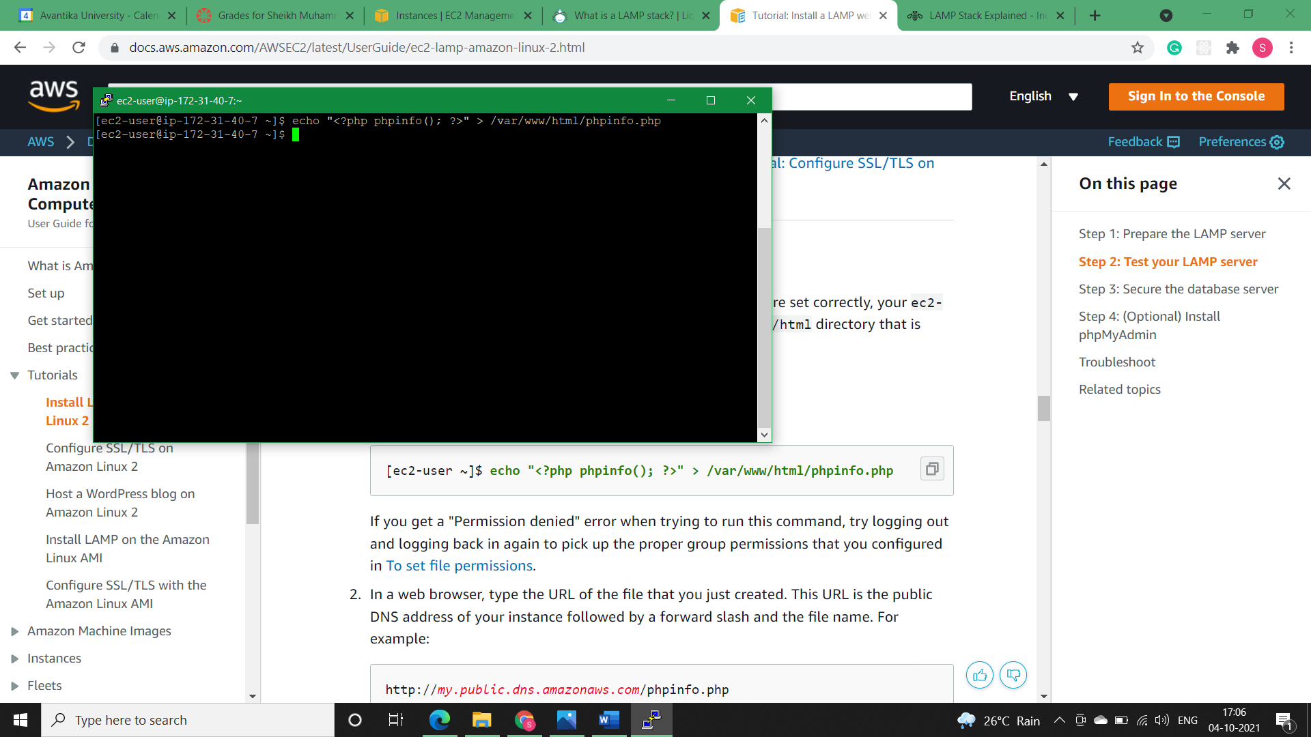

* **Step2)** In a web browser, type the URL of the file that we just created. This URL is the public DNS address of our instance followed by a forward slash and the file name. i.e., *http://ec2-13-126-73-151.ap-south-1.compute.amazonaws.com/phpinfo.php*

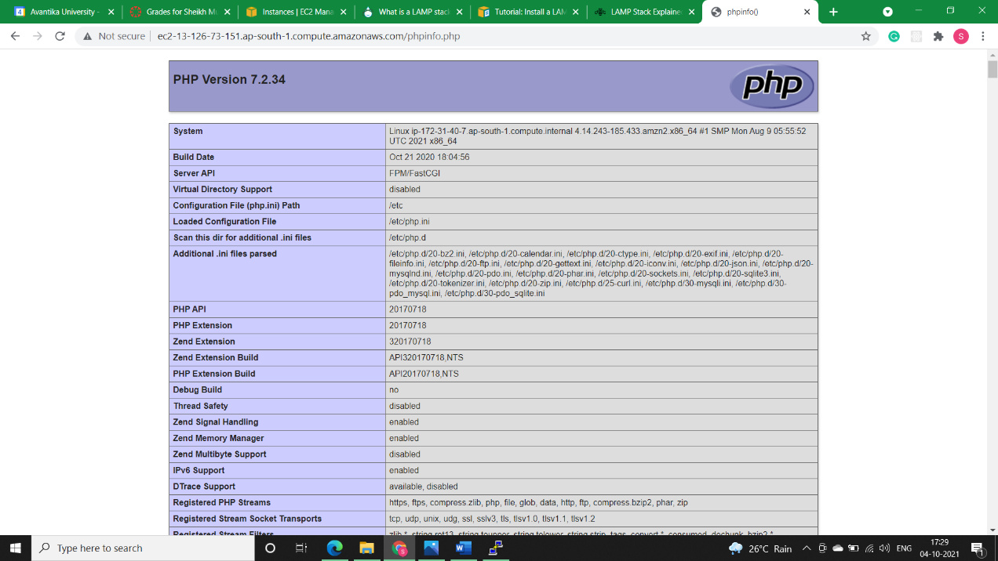

* **Step3)** Delete the phpinfo.php file. Although this can be useful information, it should not be broadcast to the internet for security reasons.

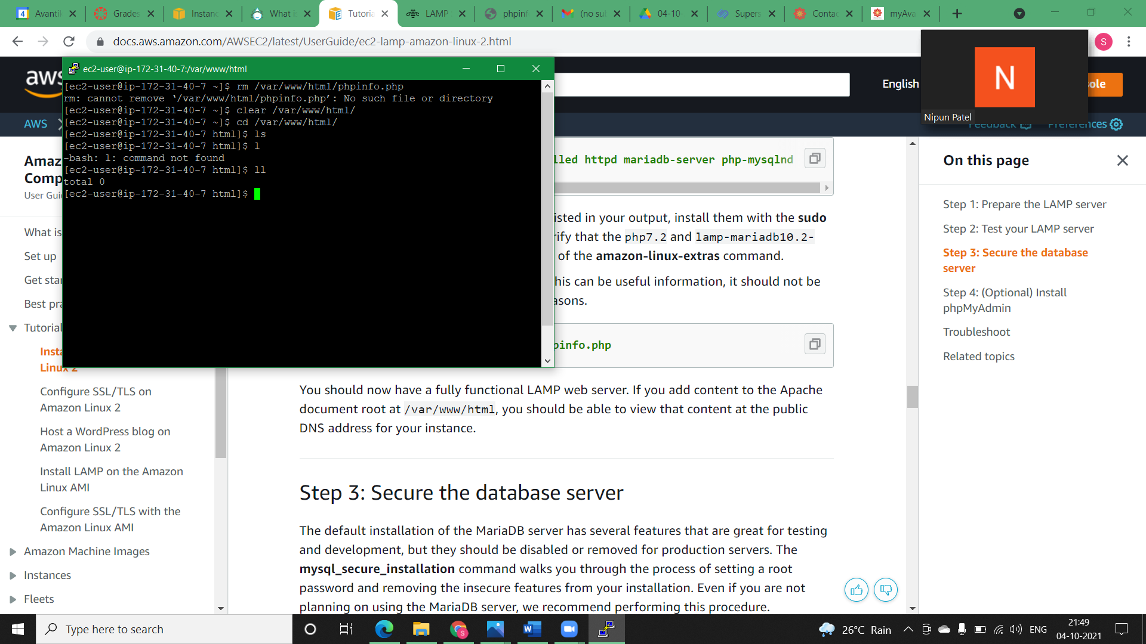

* **Solution 1, Practical (Securing the database server):**
* **Brief:**

The default installation of the MariaDB server has several features that are great for testing and development, but they should be disabled or removed for production servers. The *mysql_secure_installation* command walks us through the process of setting a root password and removing the insecure features from our installation. Even if we are not planning on using the MariaDB server, aws recommend performing this procedure.

* **Step1)** Start the MariaDB server.

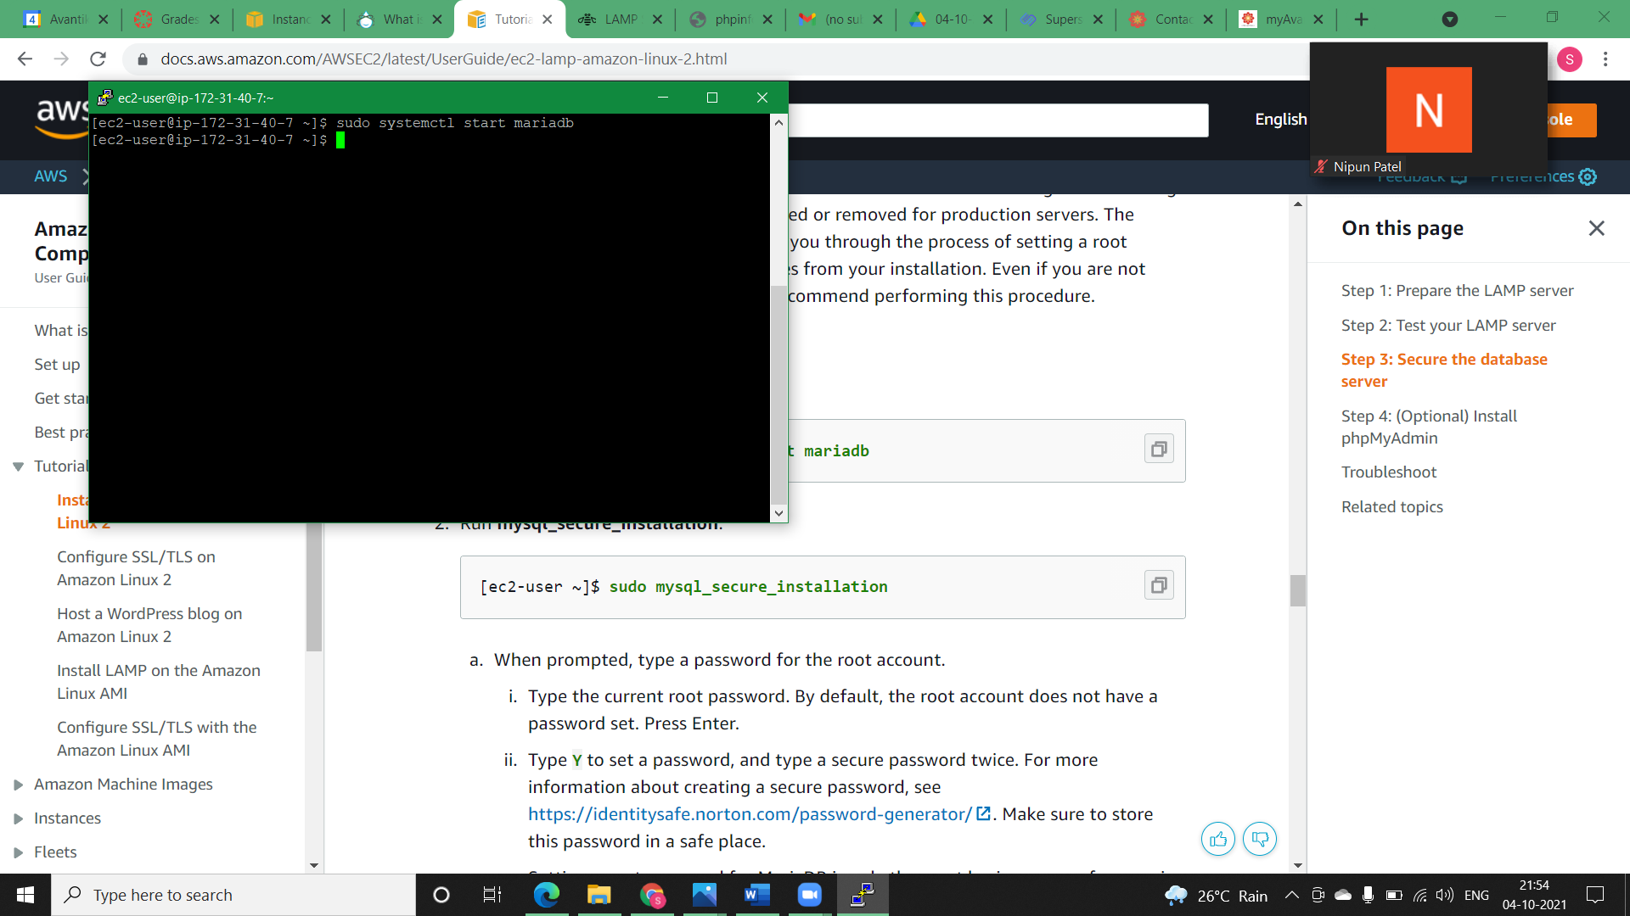

* **Step2)** Run *mysql_secure_installation.*

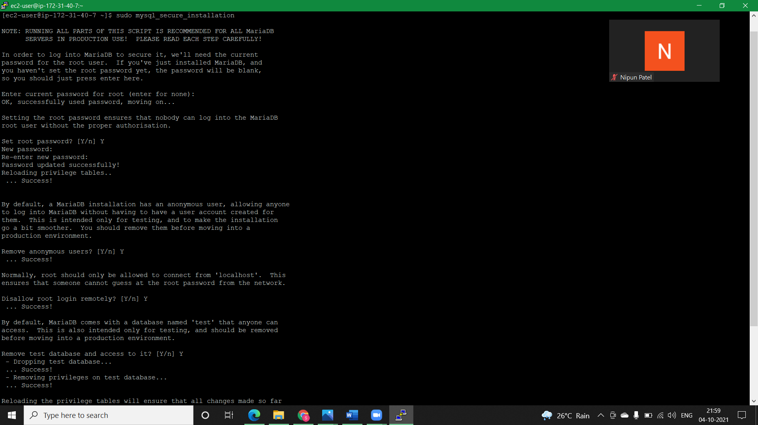

* **Step2.1)** Type the current root password. By default, the root account does not have a password set. Press Enter.



* **Step2.2)** Type Y to set a password, and type a secure password twice.



* **Step2.3)**

Type **Y** to remove the anonymous user accounts.

Type **Y** to disable the remote root login.

Type **Y** to remove the test database.

Type **Y** to reload the privilege tables and save your changes.



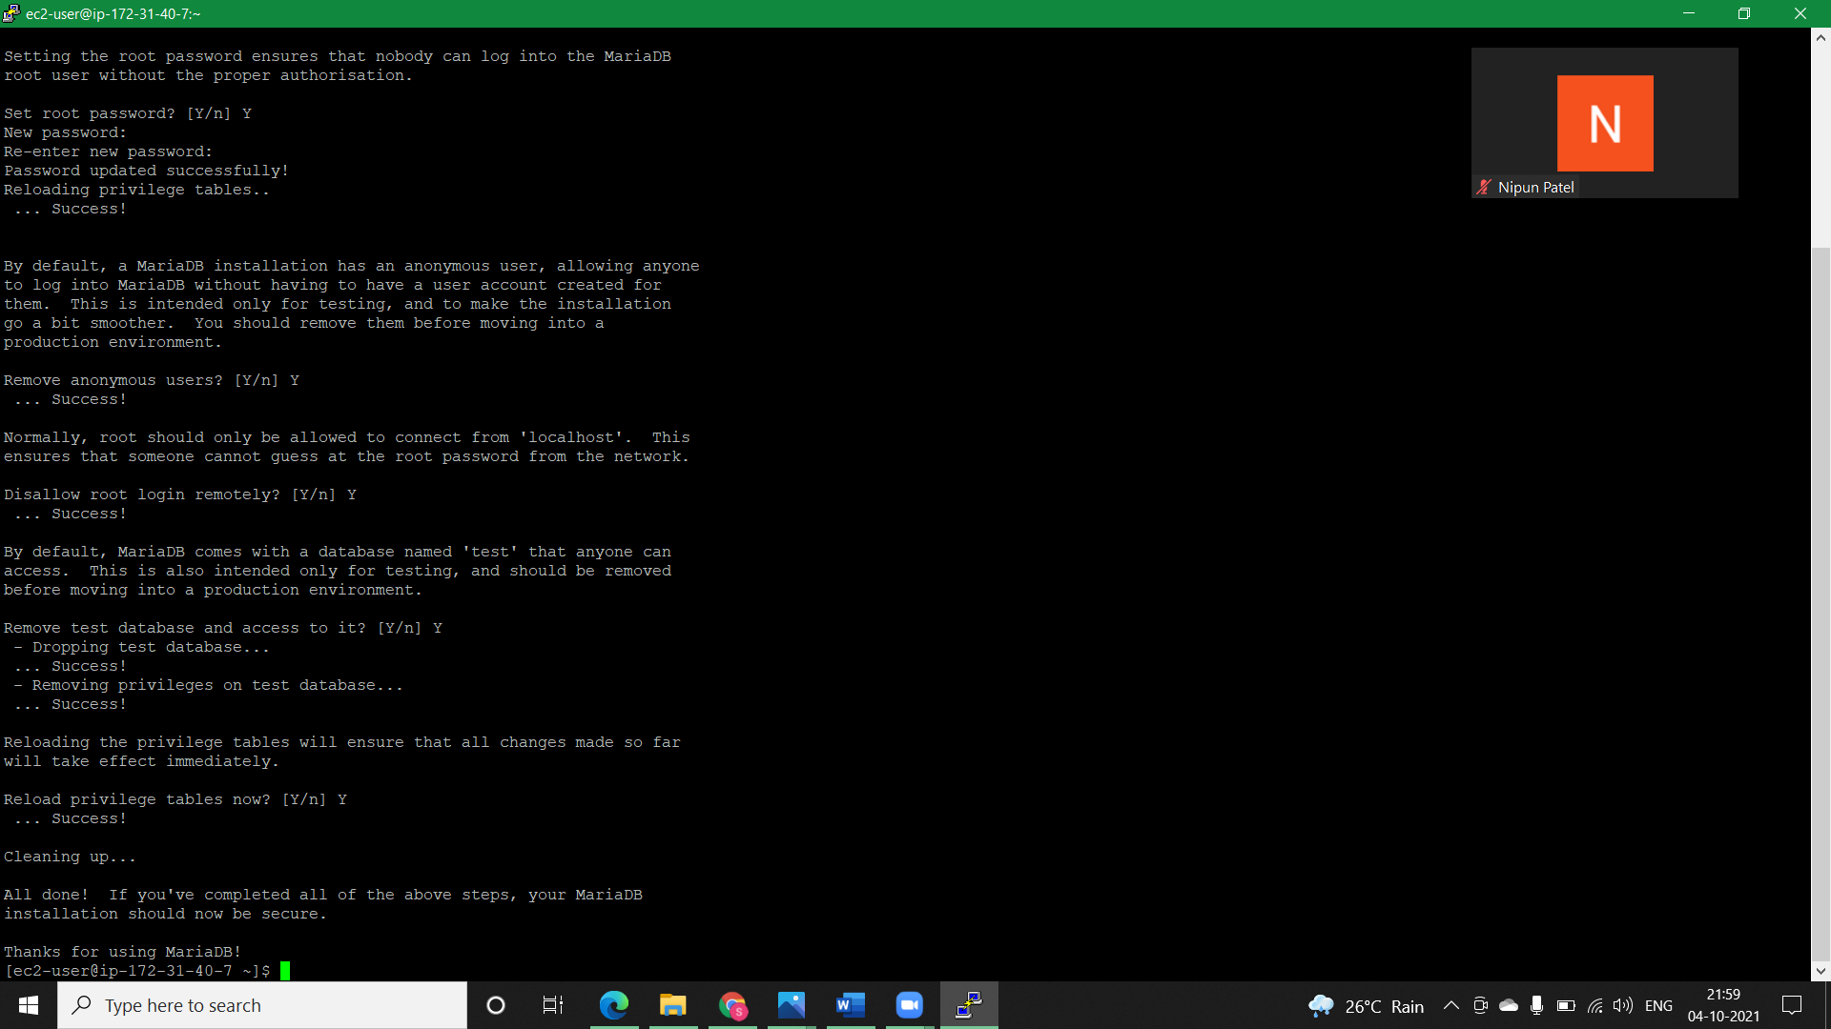

* **Step3)** (Optional) If you want the MariaDB server to start at every boot, type the following command.

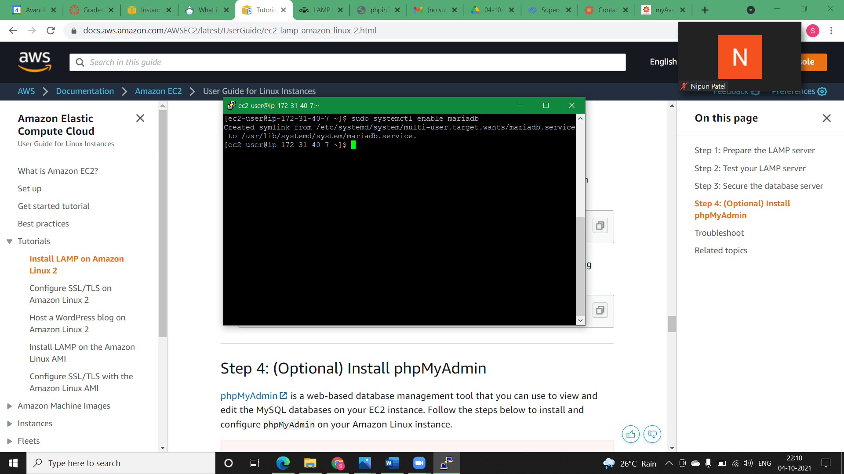

* **Solution 1, Practical (Install phpMyAdmin):**
* **Brief:**

phpMyAdmin is a web-based database management tool that you can use to view and edit the MySQL databases on your EC2 instance. Follow the steps below to install and configure phpMyAdmin on your Amazon Linux instance.

**NOTE:** AWS do not recommend using phpMyAdmin to access a LAMP server unless you have enabled SSL/TLS in Apache; otherwise, your database administrator password and other data are transmitted insecurely across the internet.

* **Step1)** Install the required dependencies.

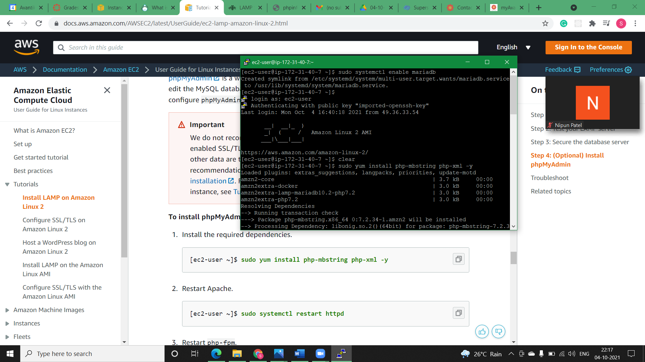

* **Step2)** Restart Apache.

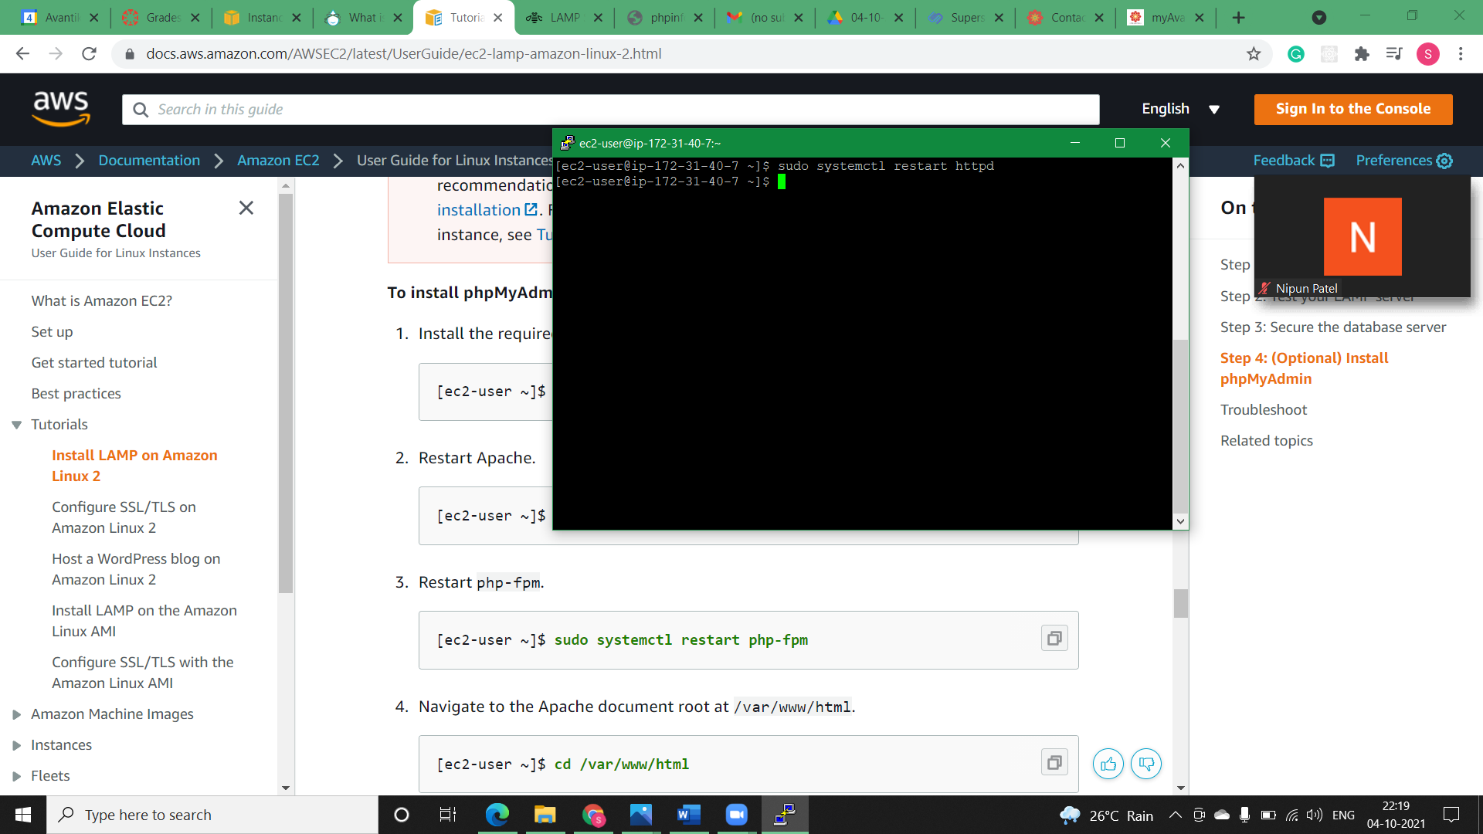

* **Step3)** Restart php-fpm.

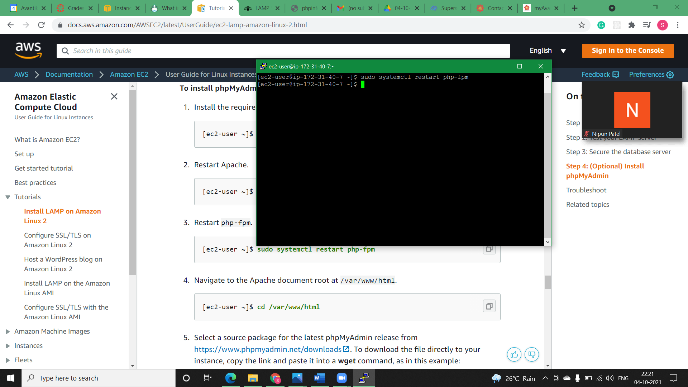

* **Step4)** Navigate to the Apache document root at /var/www/html.

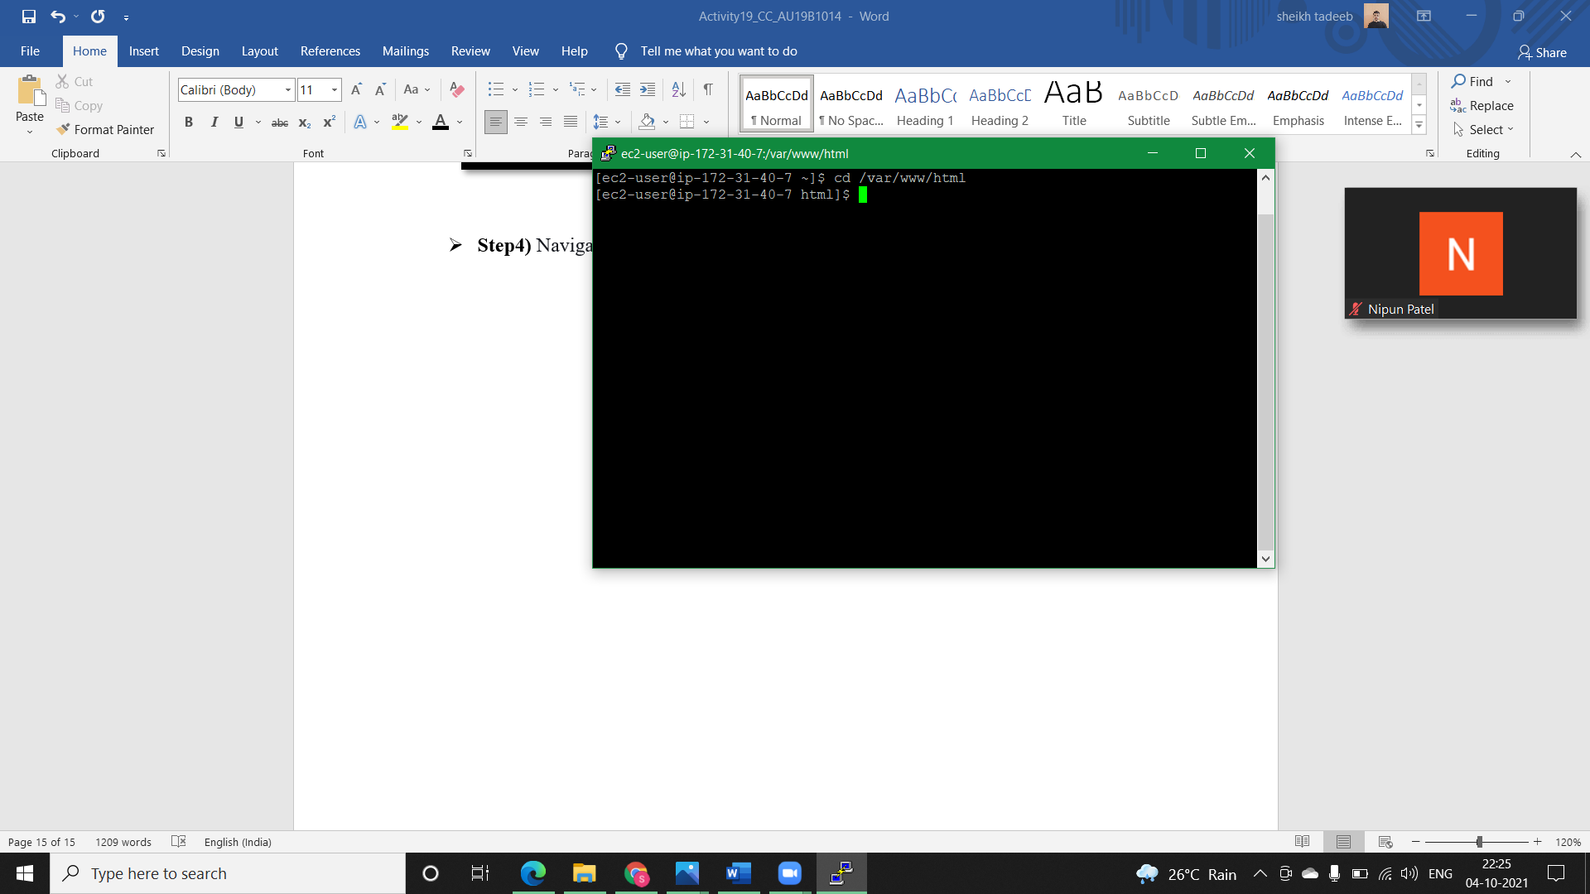

* **Step5)** Select a source package for the latest phpMyAdmin release from <https://www.phpmyadmin.net/downloads>. To download the file directly to your instance, copy the link and paste it into a **wget** command, as in this example:

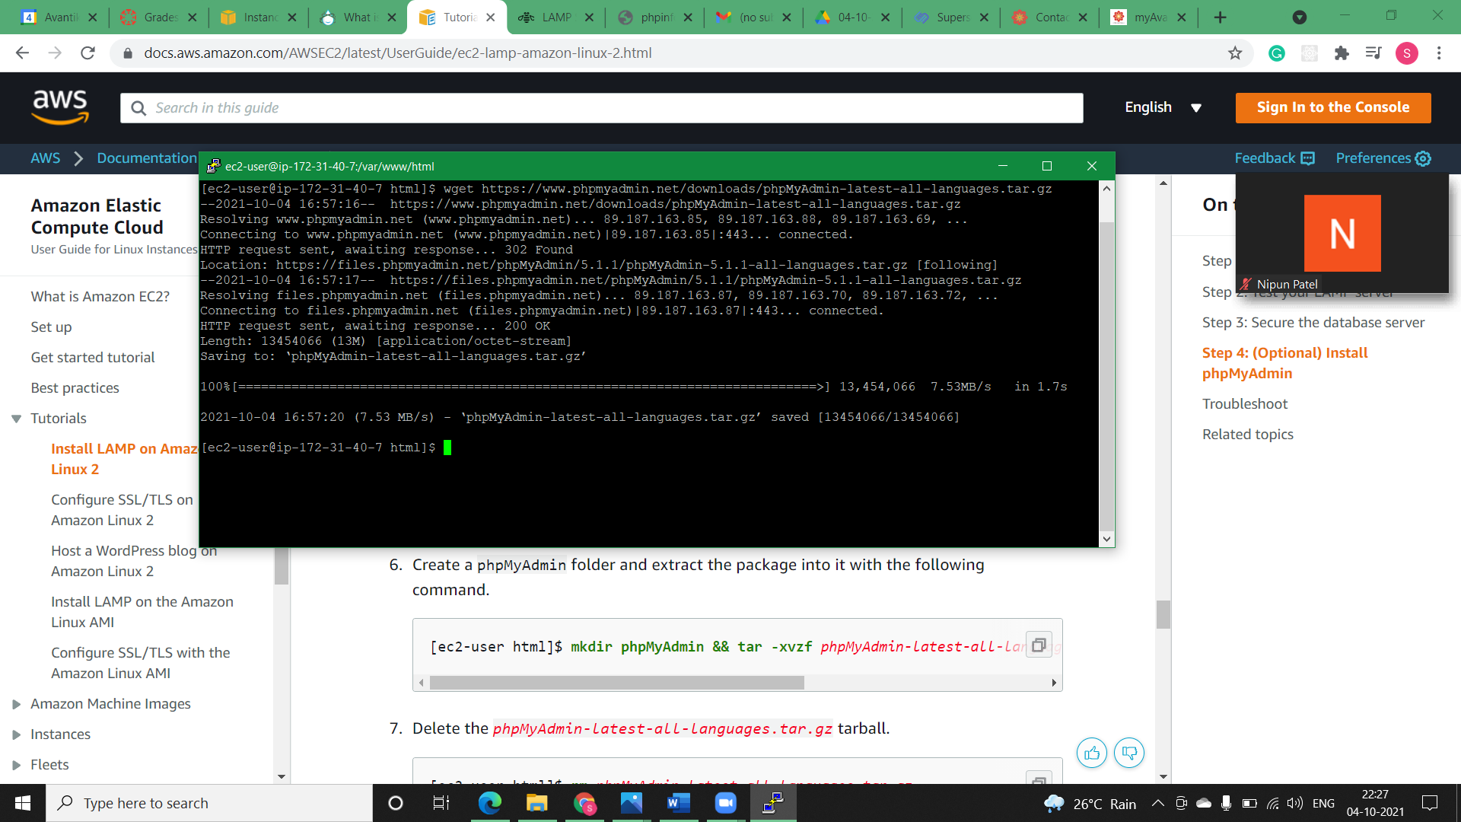

* 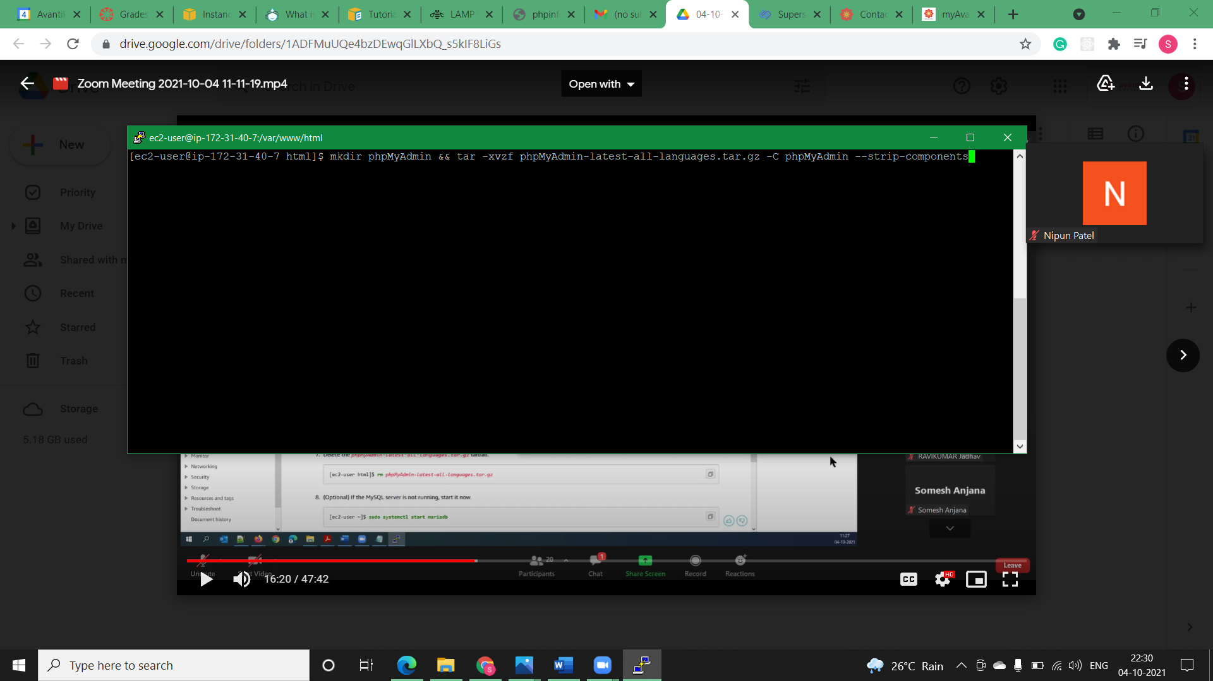**Step6)** Create a phpMyAdmin folder and extract the package into it with the following command.

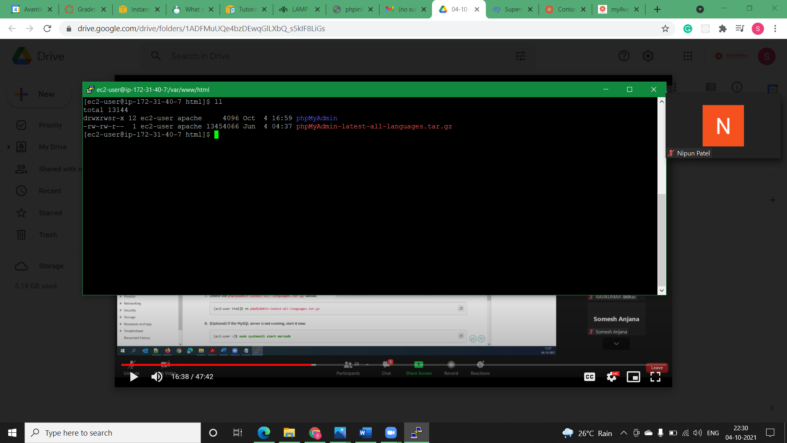

* **Step7)** Delete the *phpMyAdmin-latest-all-languages.tar.gz* tarball.

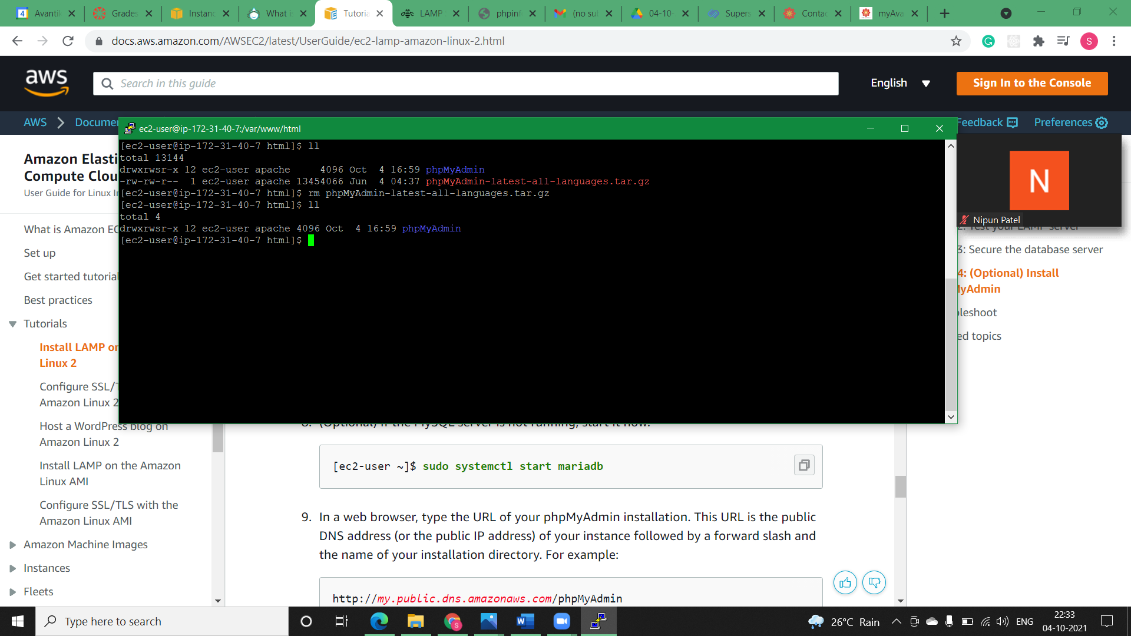

* **Step8)** In a web browser, type the URL of our phpMyAdmin installation. This URL is the public DNS address (or the public IP address) of our instance followed by a forward slash and the name of our installation directory. i.e.,

*http://ec2-13-126-73-151.ap-south-1.compute.amazonaws.com/phpMyAdmin*

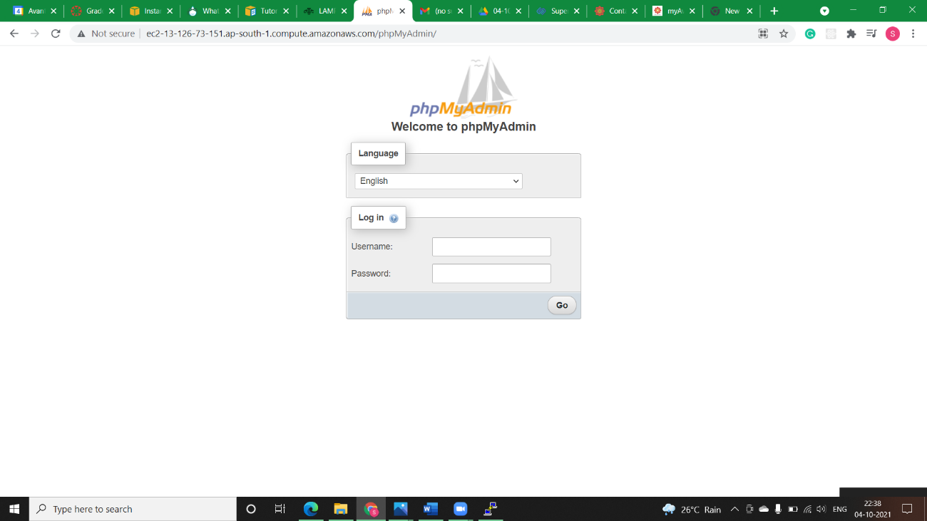

* **Step9)** Log in to your phpMyAdmin installation with the root user name and the MySQL root password you created earlier.

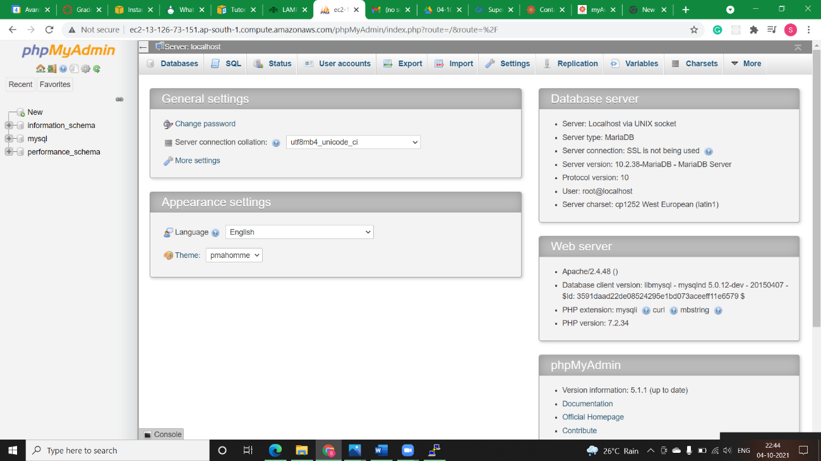

* **Step10)** Our installation must still be configured before you put it into service. Aws suggest that we begin by manually creating the configuration file, as follows:

1. To start with a minimal configuration file, use your favorite text editor to create a new file, and then copy the contents of config.sample.inc.php into it.

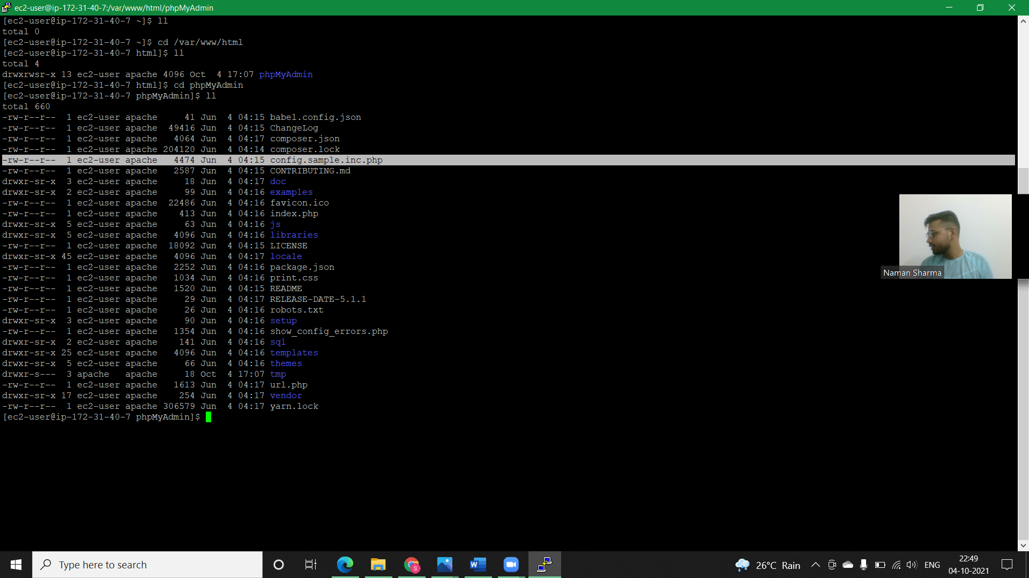

1. Save the file as config.inc.php in the phpMyAdmin directory that contains index.php.

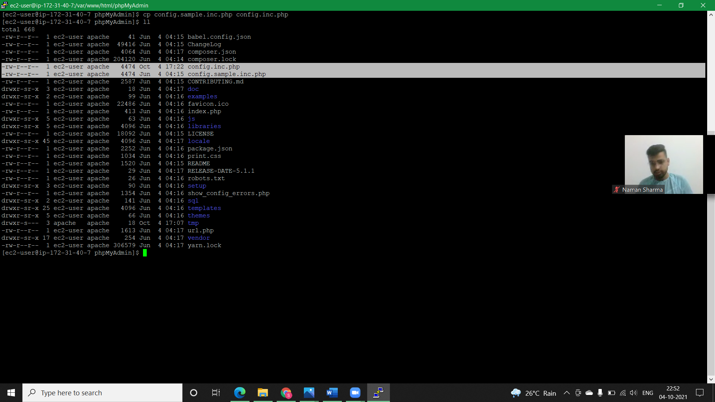

* **Solution 1, Configure SSL/TLS on Amazon Linux 2:**
* **Brief:**

Secure Sockets Layer/Transport Layer Security (SSL/TLS) creates an encrypted channel between a web server and web client that protects data in transit from being eavesdropped on. While web browsers still support SSL, its successor protocol TLS is less vulnerable to attack. Amazon Linux 2 disables server-side support for all versions of SSL by default

* **Step1)** To enable TLS on our server we would Connect to your instance and confirm that Apache is running.

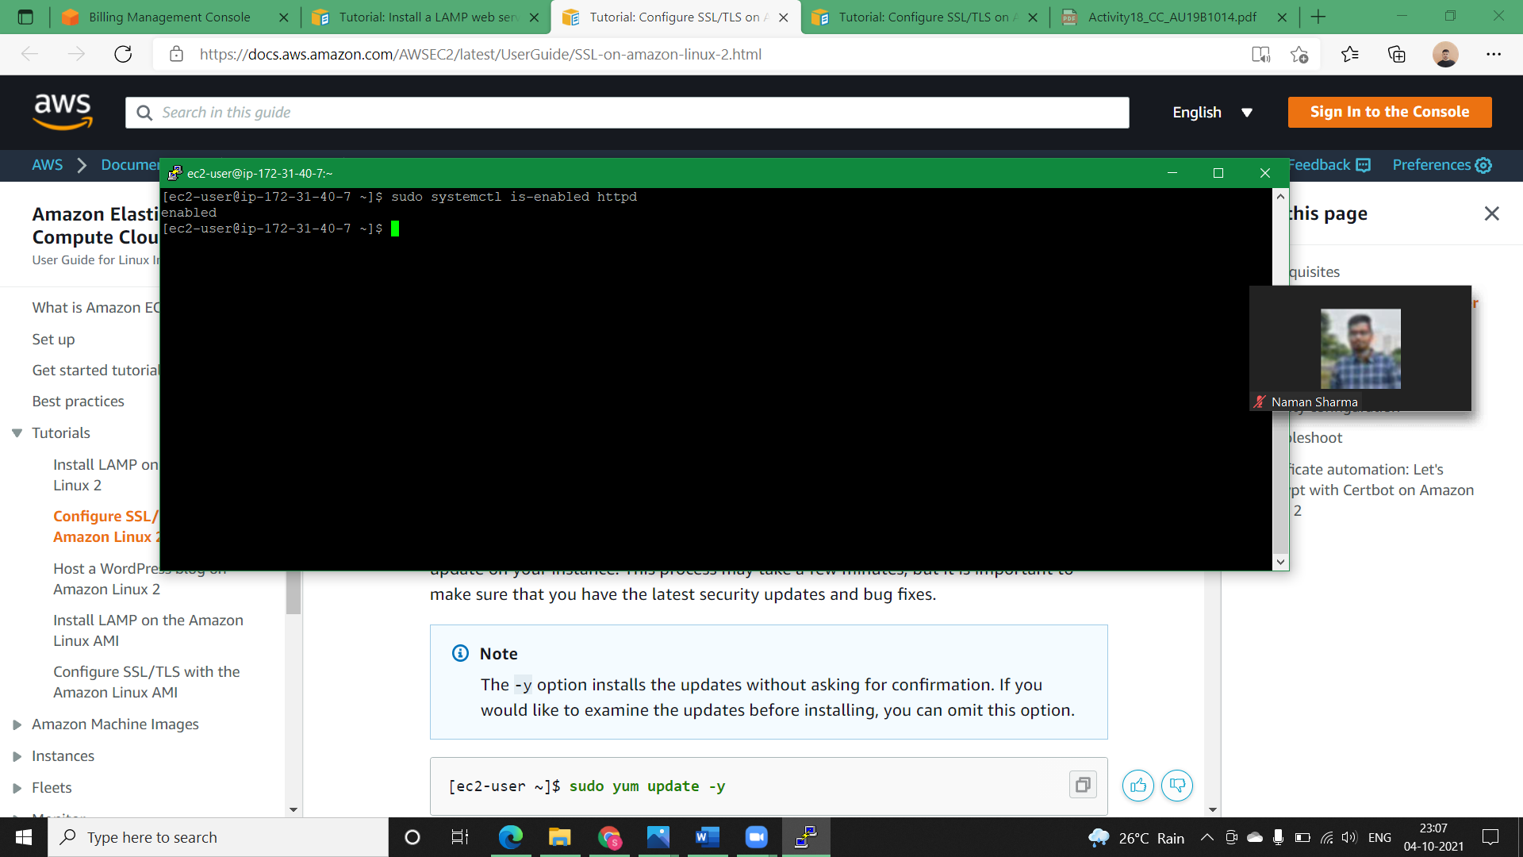

* **Step2)** To ensure that all of your software packages are up to date, perform a quick software update on your instance. The -y option installs the updates without asking for confirmation.

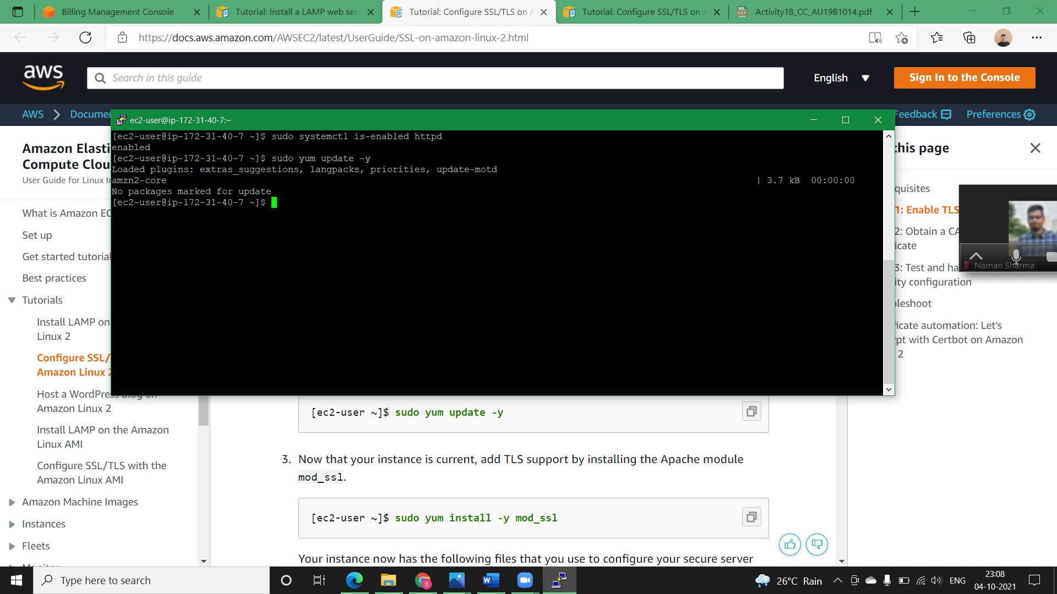

* 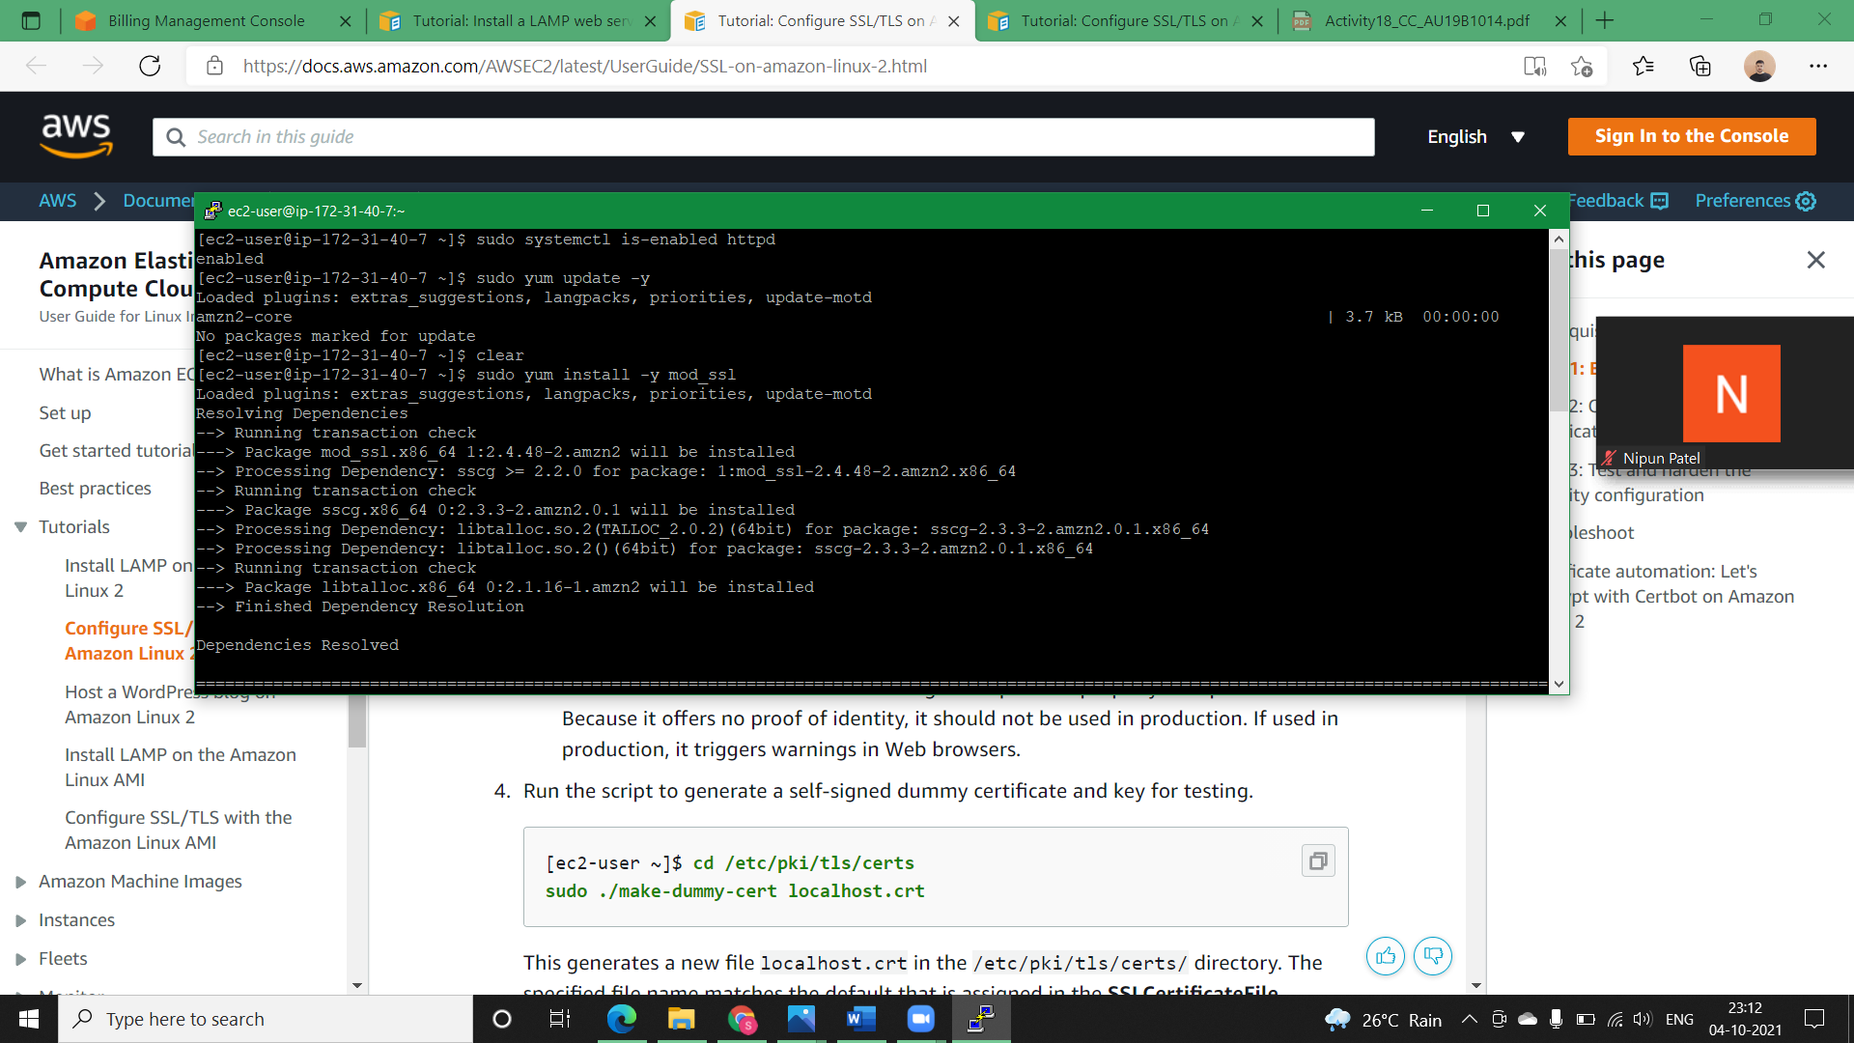**Step3)** Now that your instance is current, add TLS support by installing the Apache module mod_ssl.

**NOTE:** Your instance now has the following files that you use to configure your secure server and create a certificate for testing:

* /etc/httpd/conf.d/ssl.conf

The configuration file for mod_ssl. It contains *directives* telling Apache where to find encryption keys and certificates, the TLS protocol versions to allow, and the encryption ciphers to accept.

* /etc/pki/tls/certs/make-dummy-cert

A script to generate a self-signed X.509 certificate and private key for your server host. This certificate is useful for testing that Apache is properly set up to use TLS. Because it offers no proof of identity, it should not be used in production. If used in production, it triggers warnings in Web browsers.

* **Step4)** Run the script to generate a self-signed dummy certificate and key for testing.

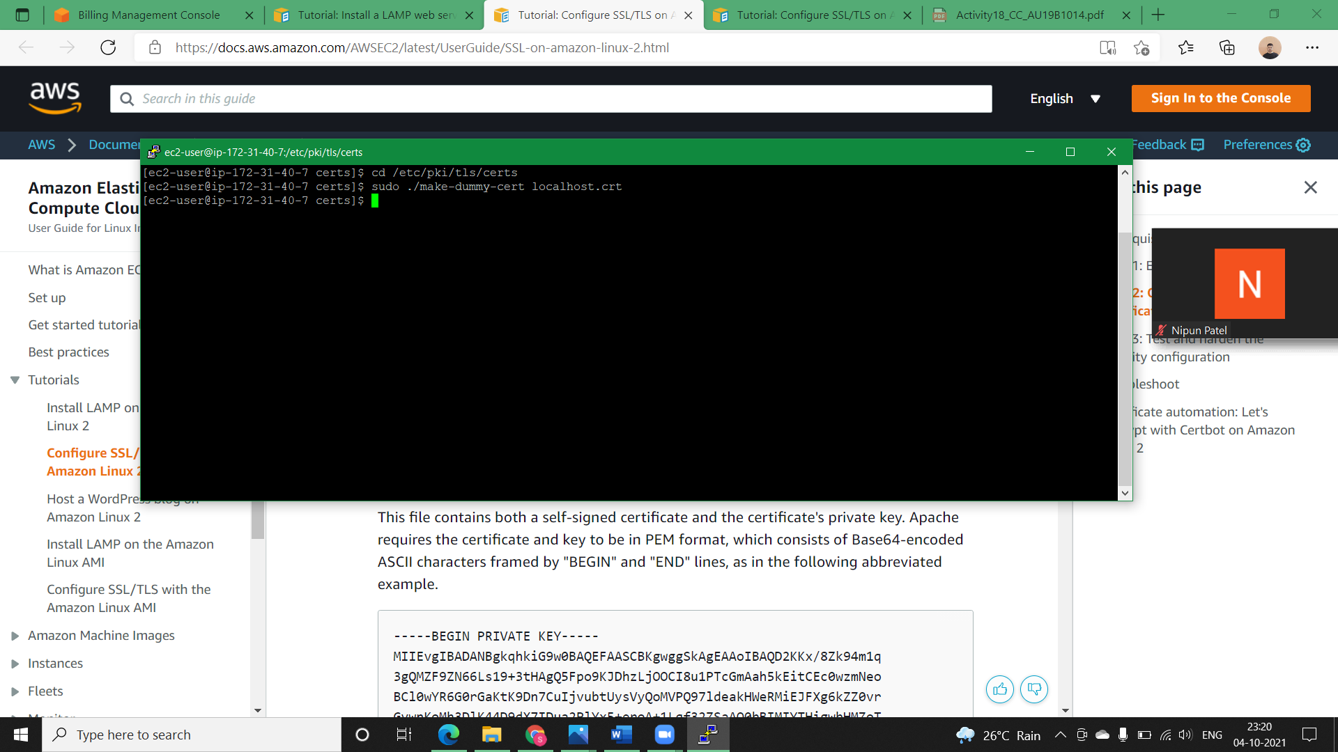

* **Step5)** Open the /etc/httpd/conf.d/ssl.conf file using your favorite text editor (such as **vim** or **nano**) and comment out the following line, because the self-signed dummy certificate also contains the key. If you do not comment out this line before you complete the next step, the Apache service fails to start.

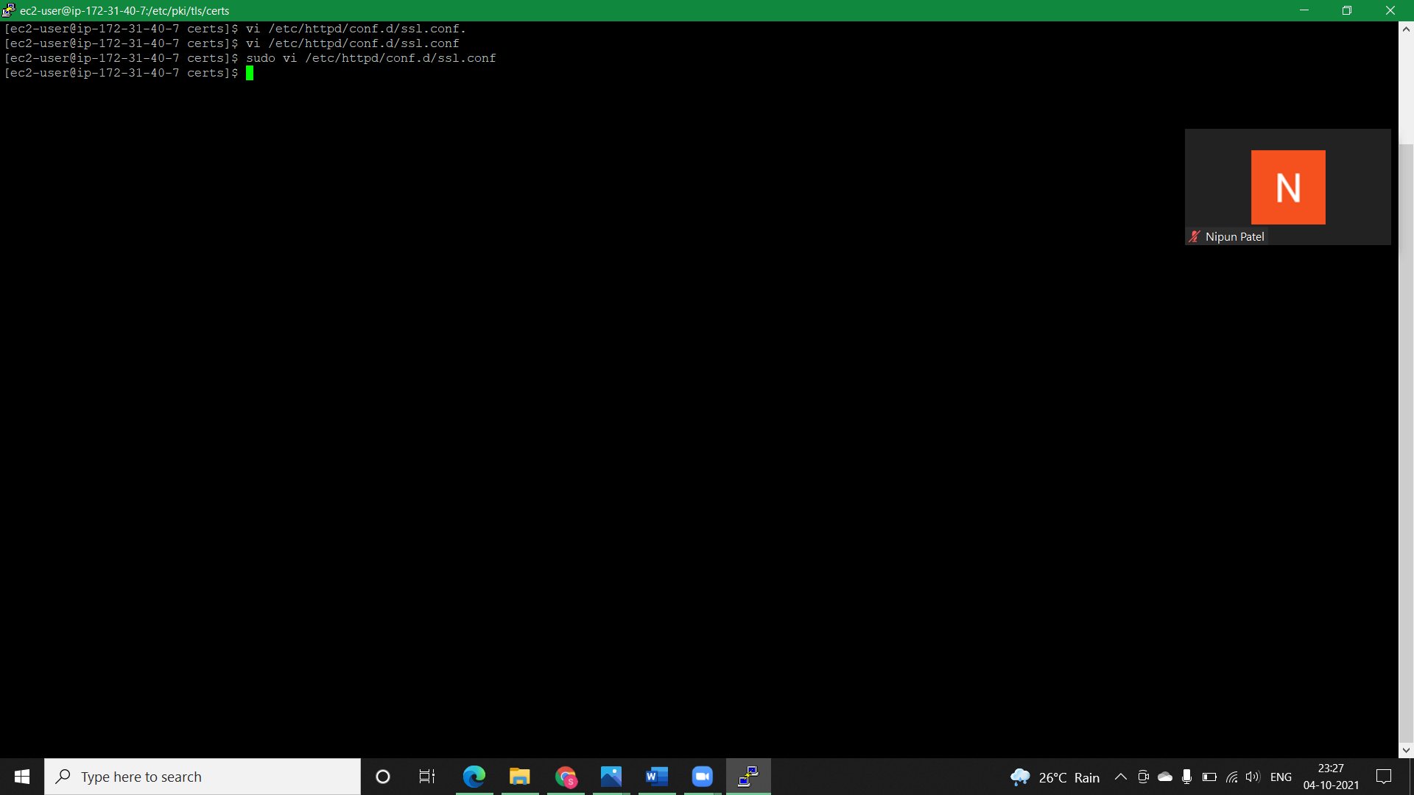

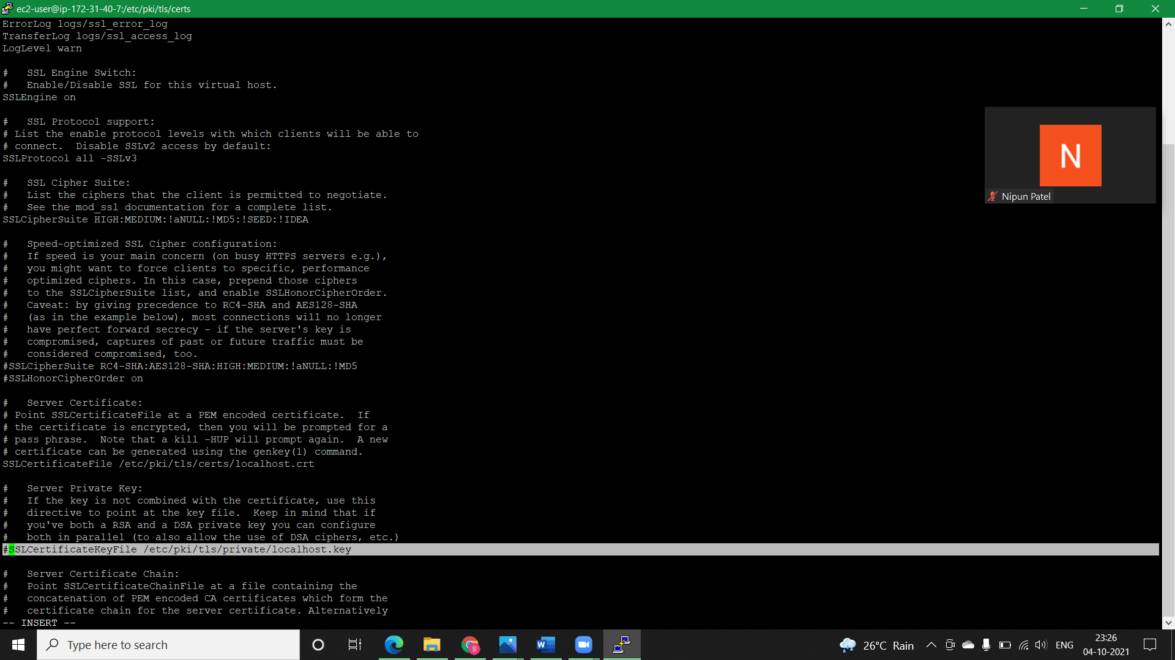

* **Step6)** Restart Apache.

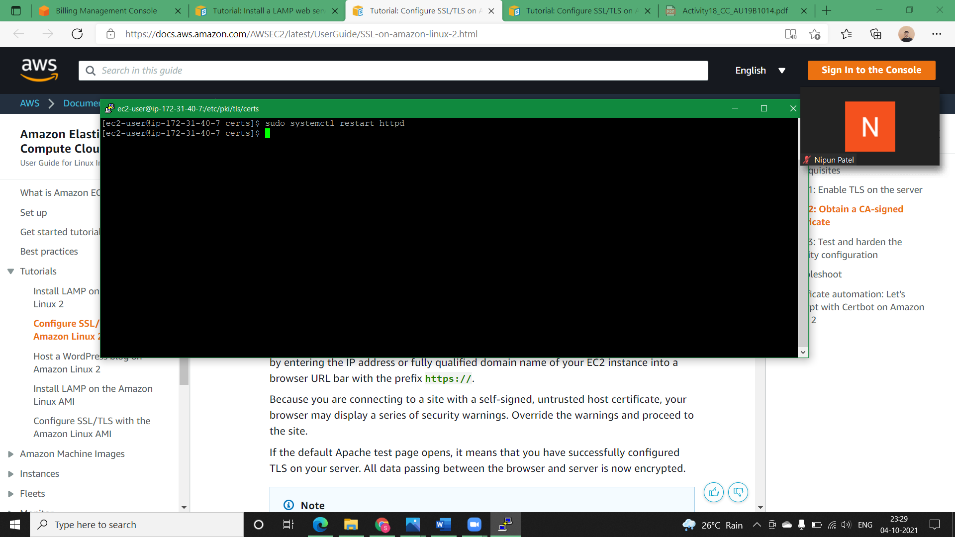

* **Step7)** Your Apache web server should now support HTTPS (secure HTTP) over port 443. Test it by entering the IP address or fully qualified domain name of your EC2 instance into a browser URL bar with the prefix **https://**.

Because you are connecting to a site with a self-signed, untrusted host certificate, your browser may display a series of security warnings. Override the warnings and proceed to the site.

If the default Apache test page opens, it means that you have successfully configured TLS on your server. All data passing between the browser and server is now encrypted.

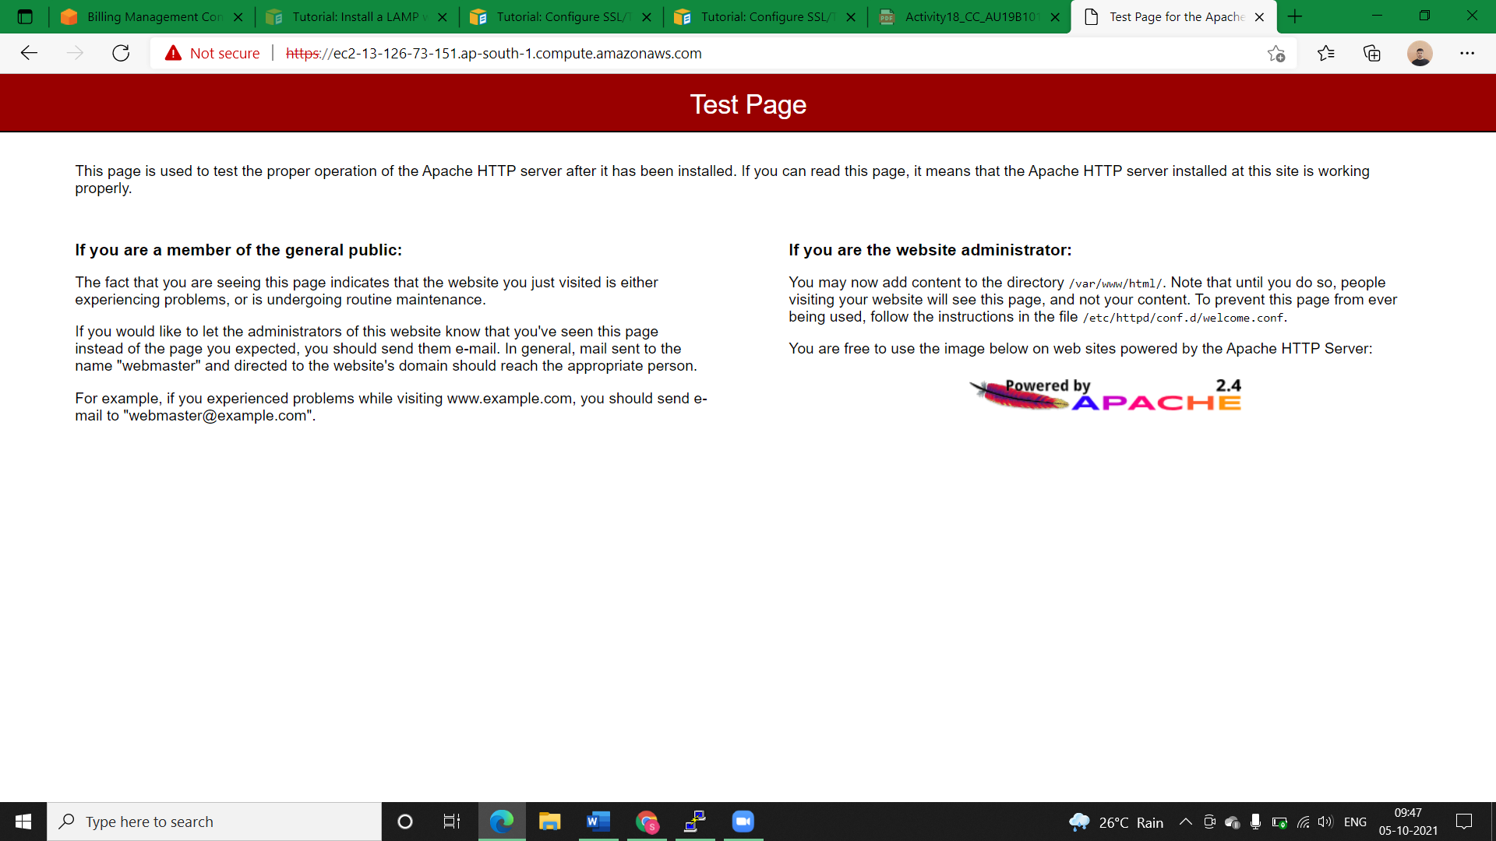

* **Solution2 (User-Script):**

NOTE: In below Bash-Script SSL/TSL enabling is not done. We can add it later.

#!/bin/bash

sudo yum update -y

sudo amazon-linux-extras install -y lamp-mariadb10.2-php7.2 php7.2

sudo yum install -y httpd mariadb-server

sudo systemctl start httpd

sudo systemctl enable httpd

sudo usermod -a -G apache ec2-user

sudo chown -R ec2-user:apache /var/www

sudo find /var/www -type f -exec sudo chmod 0664 {} \;

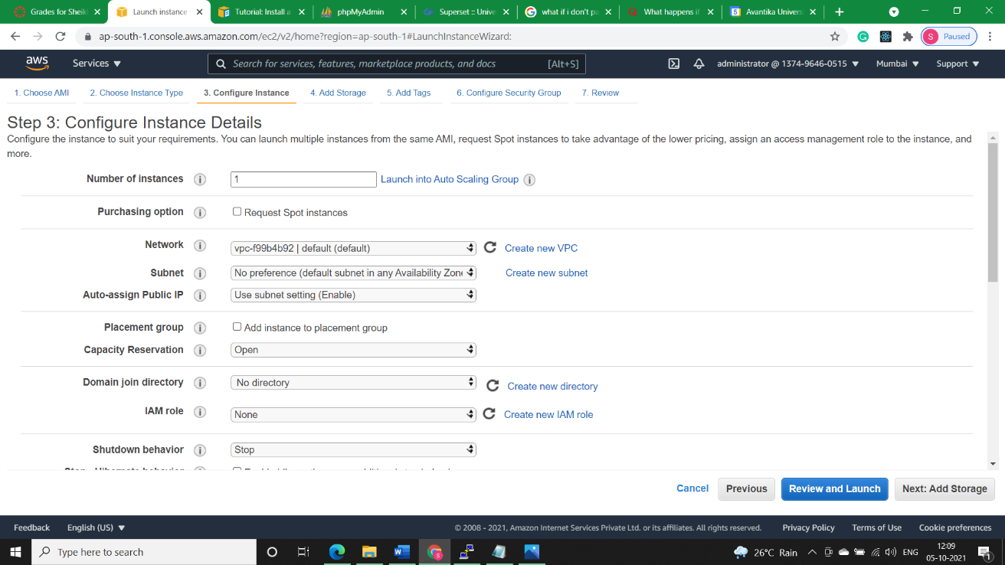

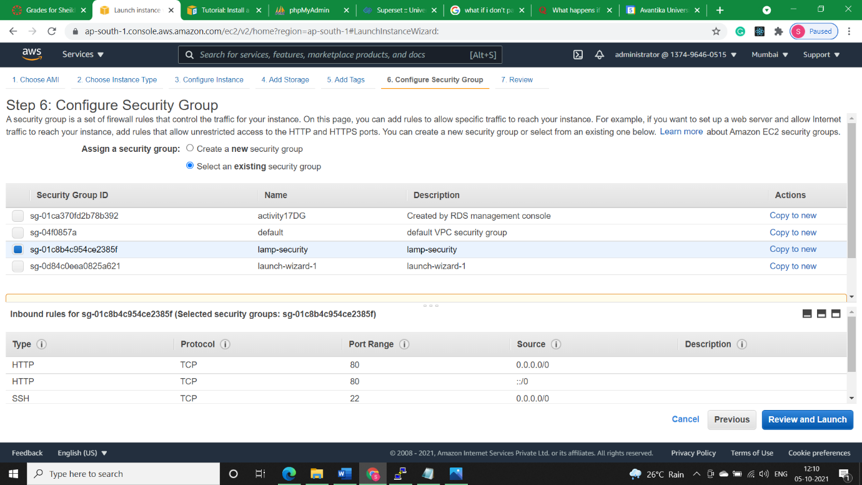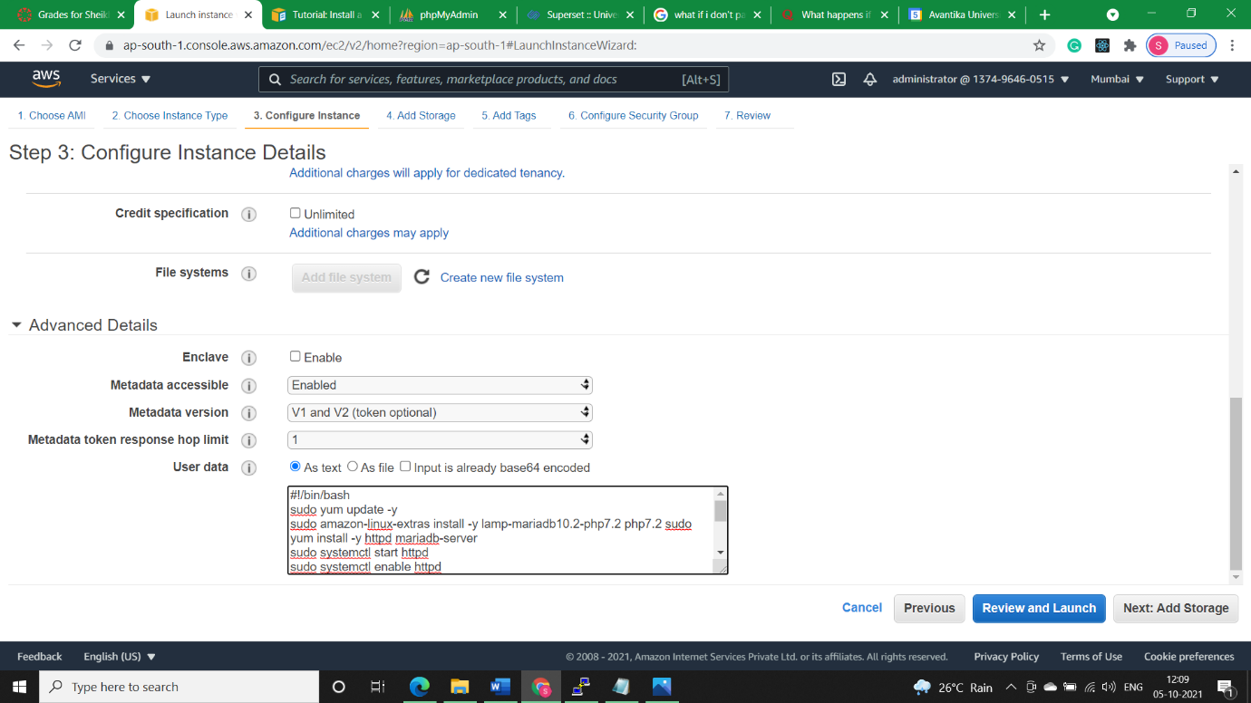

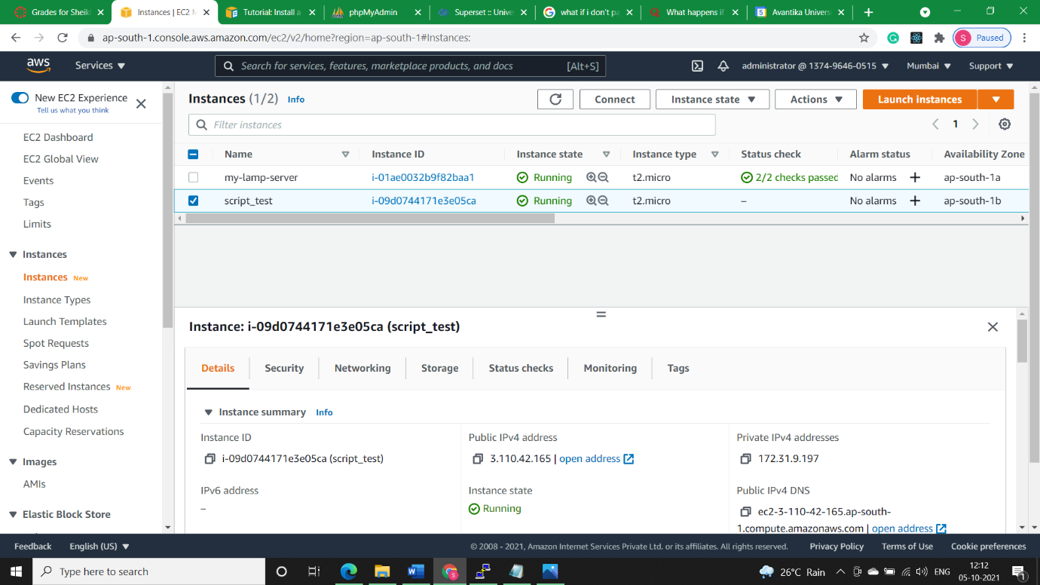

* Test our web server. In a web browser, type the public DNS address (or the public IP address) of our instance. If there is no content in /var/www/html, we should see the Apache test page. We can get the public DNS for our instance using the Amazon EC2 console (check the Public DNS column; if this column is hidden, choose Show/Hide Columns (the gear-shaped icon) and choose Public DNS).

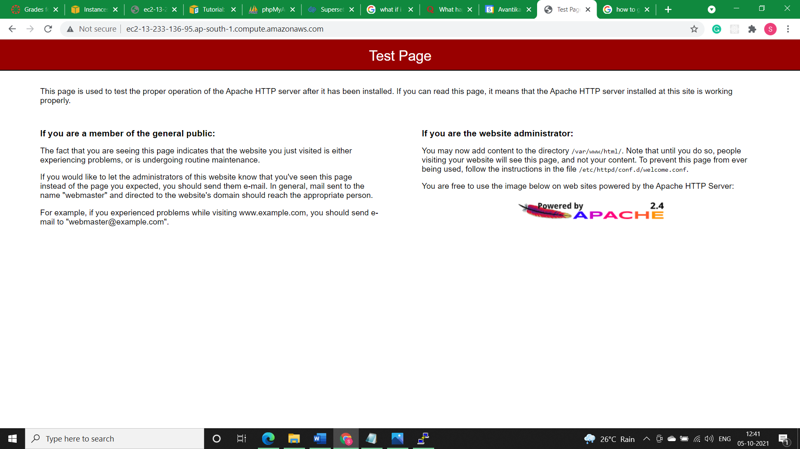

* 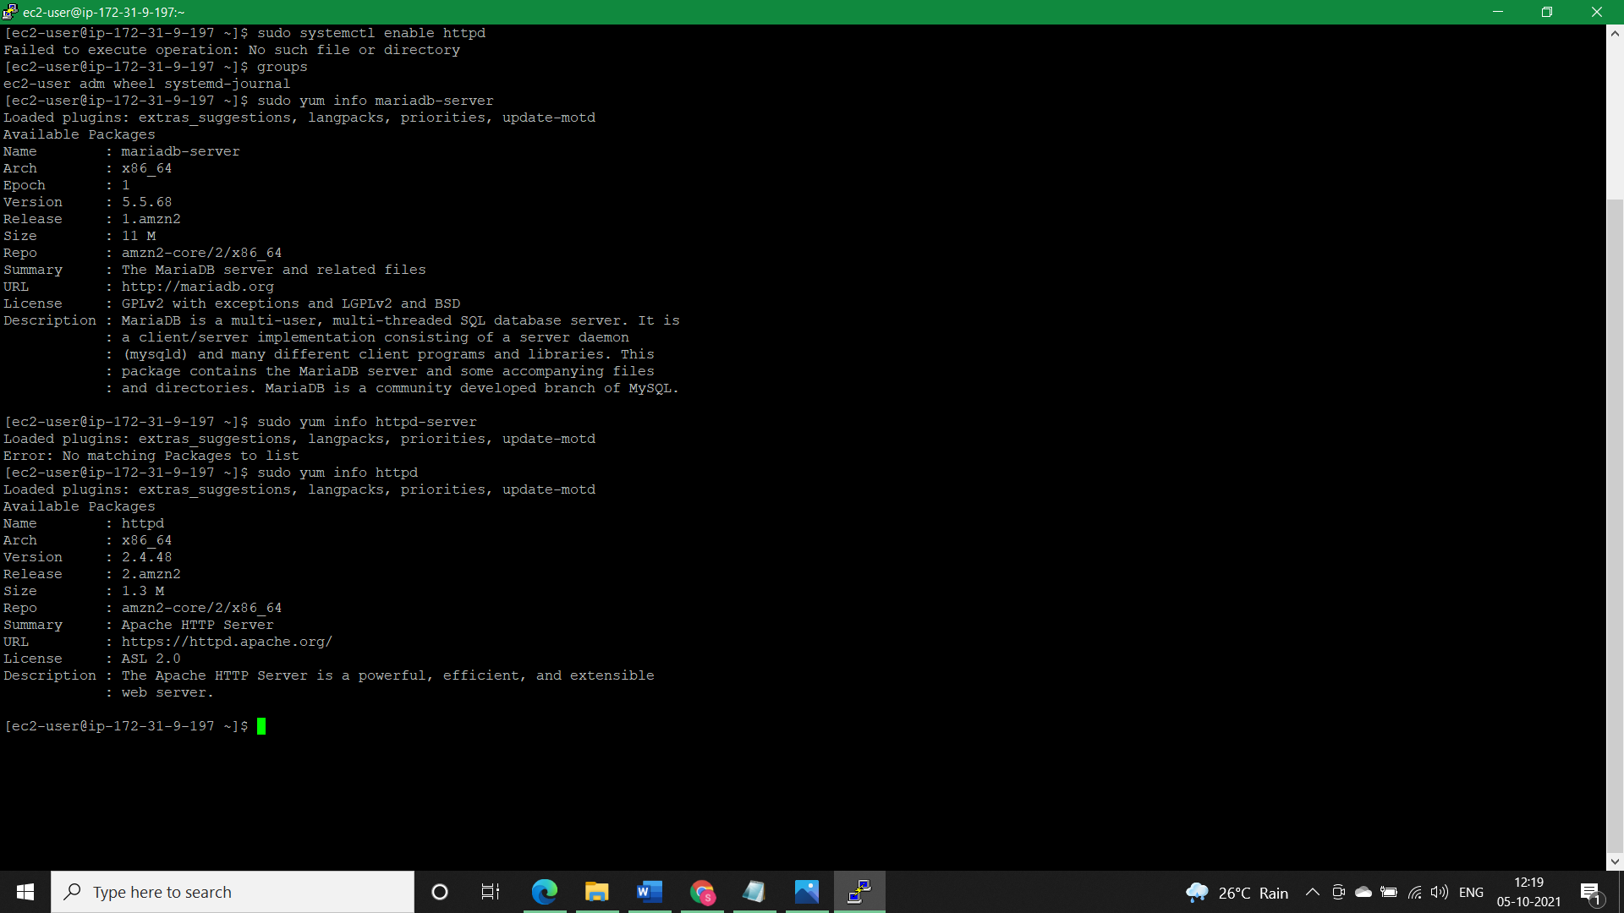We can also check from putty console whether all our packages are installed in our new machine or not